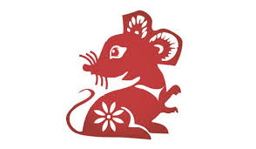

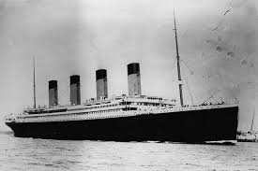
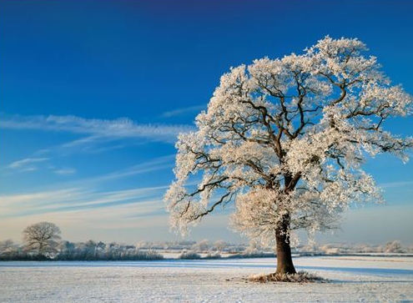
DIS Year 1
Ice and Fire – Spring 1
RE:
To recognise some artefacts and stories from world religions.eg Special books, prayer mats
To look at similarities and differences between us and ensure that we know everyone is equal,

Star Words:
Judaism , Bible, Islam , Koran, Prayer mat Church, Synagogue, Mosque
Year of the Rat, celebration, special, same/different/equal.

Key Knowledge:
How Chinese New Year is celebrated and to retell the story.

History:
To learn and recall facts about real events beyond living memory and order events on a timeline.

Star Words:
Timeline, past/present/future, then and now.

Key Knowledge:
To order the key events of the sinking of the Titanic.
To recall facts about the Titanic.
To explain how we know something happened in the past.

Other Curriculum Areas:

PE: Swimming for Hedgehogs, gymnastics – combining skills to make a simple movement sequence.
Computing: BBC Bitesize Dance Mat Typing.
Music: Exploring rhythm
Composer – Charlotte Bray.
SEAL: Going for Goals
Art: Drawing skills using different media.
DT: To use a range of materials to design and build a boat.

Science:
To observe changes across the four seasons.

Star Words:
Weather, Winter, cold, snow, hail, frost, fog, deciduous trees, evergreen trees, day, night.

Key Knowledge:
Seasonal changes:
What seasonal changes we see in the UK in winter; weather, length of days, key events/celebrations.

