Go to the Dobcroft summer fair!

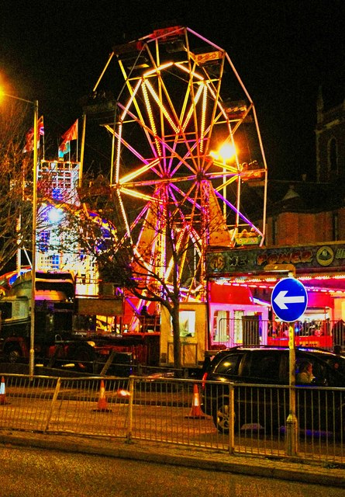

Saturday 1st july 12pm till 4pm.
Have fun on the day of the summer fair!

