COME TO THE DOBCROFT SUMMETR FAIR.
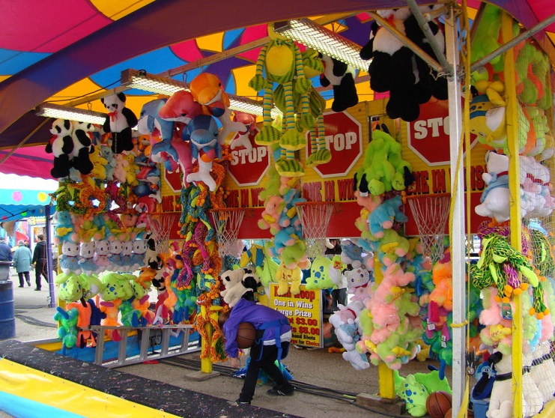


Saturday 1st July 12pm until 4pm .

Ruby Sophie

