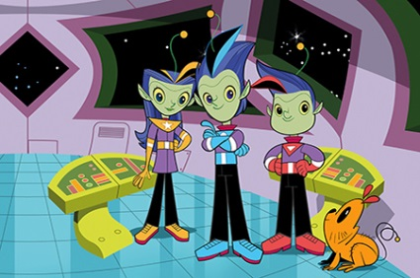

The Spelling Zone to the spelling zone

Mercury | Venus | Earth | Mars | Jupiter | Saturn | Uranus | Neptune
after | again | any | behind | both | break | busy | child
beautiful | climb | clothes | cold | would | door | even | children
because | father | find | told | could | eye | every | Christmas
people | grass | half | gold | should | floor | everybody | improve
great | kind | many | hold | money | most | move | Mr
hour | mind | only | old | parents | poor | prove | Mrs
pretty | water | who | whole | wild | sure | sugar | steak

