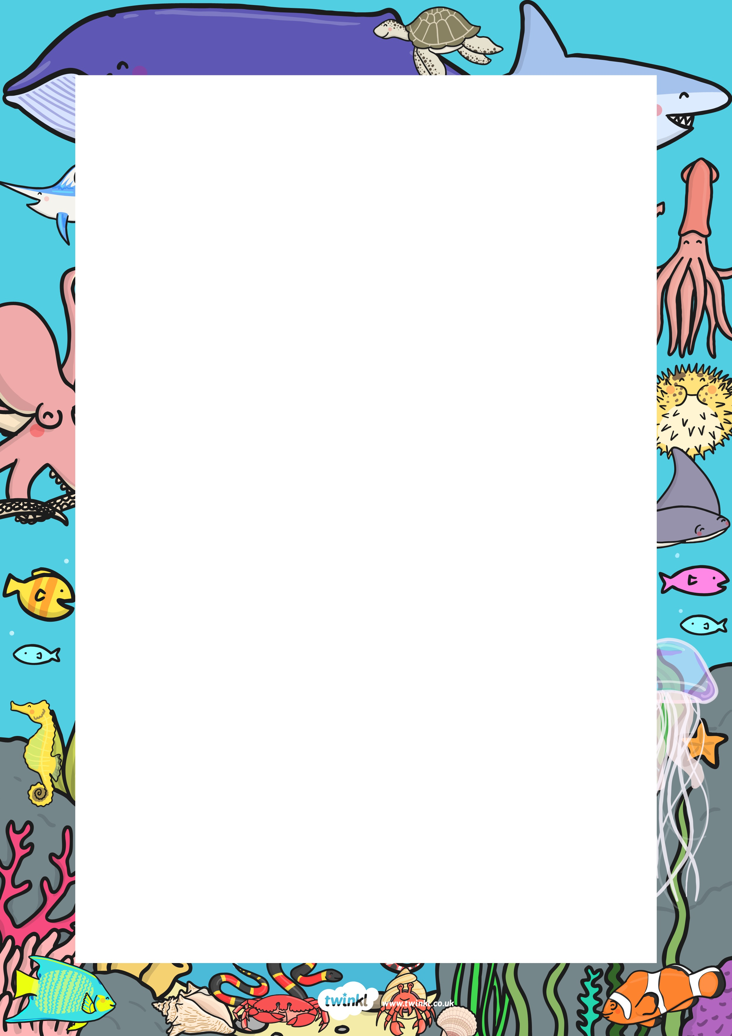
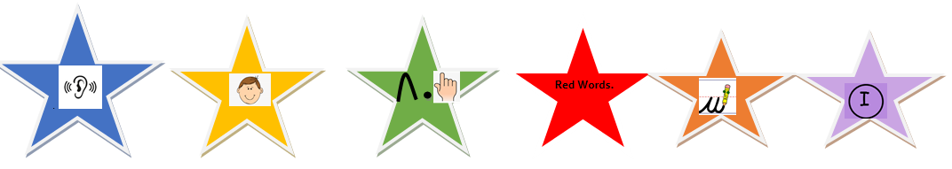
Walt- Retell a story
Wilf- Children who can sequence events
Children who can write a beginning, middle and end.
Children who can use story book language.

By

