Number of Sea Creatures | 8
Number of Sea Creatures | 7
Number of Sea Creatures | 6
Number of Sea Creatures | 5
Number of Sea Creatures | 4
Number of Sea Creatures | 3
Number of Sea Creatures | 2
Number of Sea Creatures | 1
 |  | 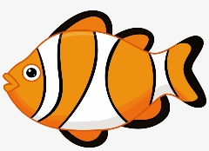 |  |  | 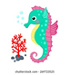
Type of sea Creature

