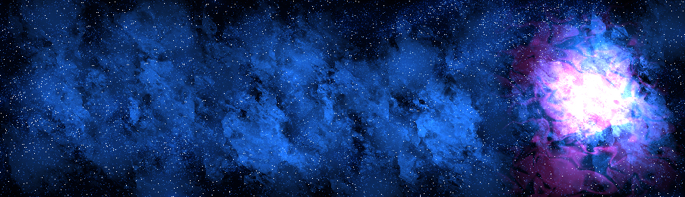
Welcome to the Year 1 spelling zone
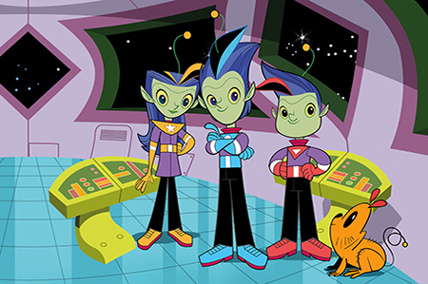

Join Alpha, Gamma and Zeta on the journey to becoming star spellers!
Remember – Practise makes perfect

Mercury | Venus | Earth | Mars | Jupiter | Saturn | Uranus | Neptune | Pluto (micro-planet)
the | do | she | you | put | our | what | here | come
a | to | we | they | push | love | when | there | some
I | no | be | was | pull | his | why | where | friend
is | go | me | with | full | her | who | were | school
 | so | he | says | of | ask | once | was | house
 |  |  | said | like

