‘To provide a foundation for fulfilled lives, inspiring confident and happy learners’
Our Values | Enjoy learning | Try our best | Make good choices | Respect each other & our surroundings | Work together | Celebrate our successes
Our Values | 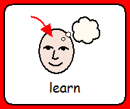 | 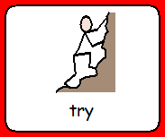 | 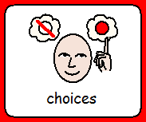 | 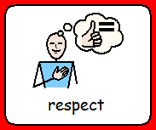 | 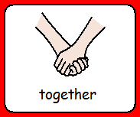 | 

Dobcroft Infant School

Welcome back Ladybirds!
Returning to school after national lockdown

w/c 8th March
Welcome back lovely Ladybirds!
We are so pleased that you are coming back to learn in our classroom very soon. All of the Ladybird teachers are excited to see you. Can you remember their names?
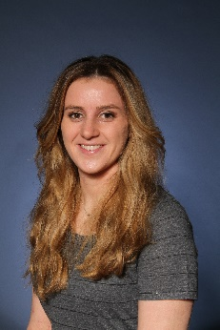  Mrs Cooke | 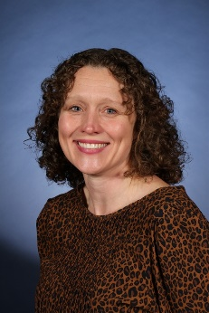  Mrs Taylor | 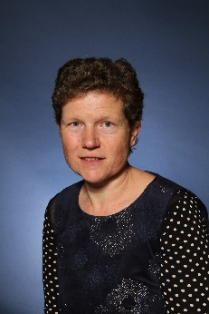  Mrs Pinder | 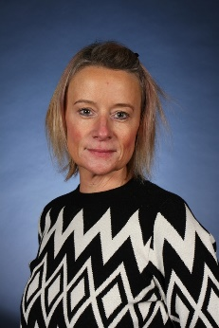  Mrs Wilson | 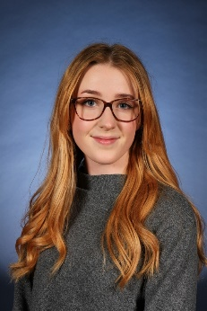  Miss Bell

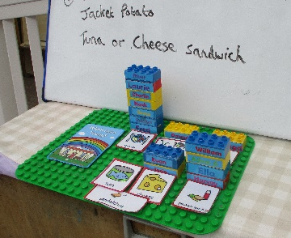
A little reminder that you can choose your dinner by putting your name block on sandwiches, school lunch at the end of the ramp before you come into the classroom.
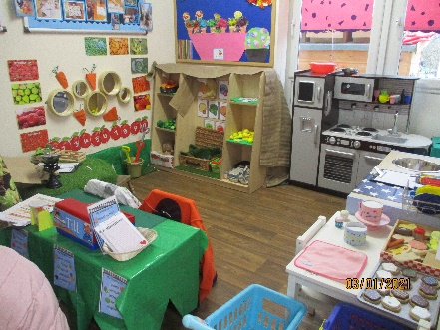

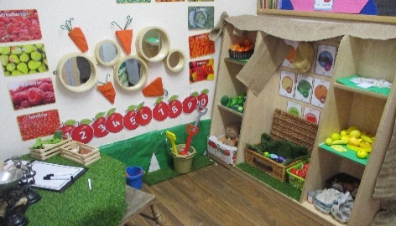
We have a new role play area inside the classroom which is a Farm Shop.
You can pretend to go shopping for different things, be the shop keeper or even sit
down for a tea party at the table!
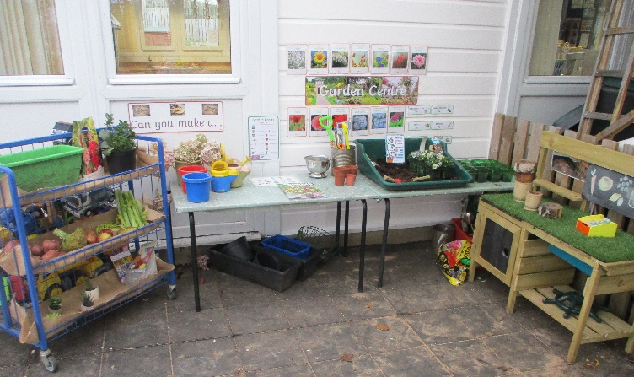

We have been busy outside too, making a garden centre
where you can dig, plant bulbs and seeds, make your own
seed packet, and buy plants and flowers with your friends.
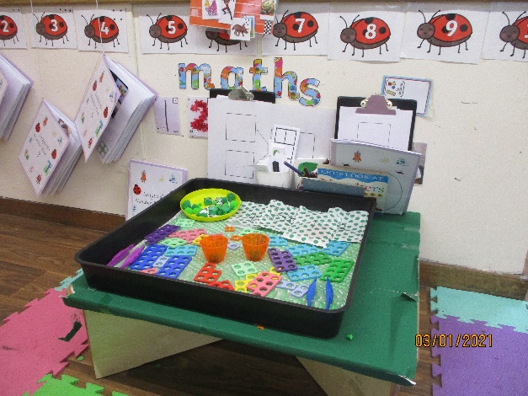
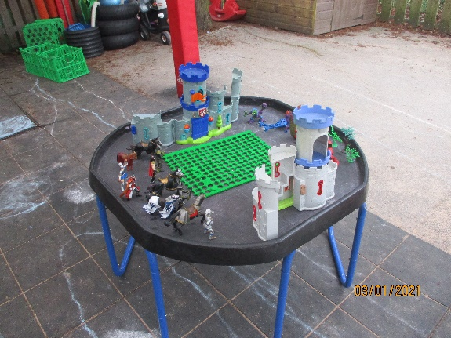

Our tuff trays inside and outside are always changing!
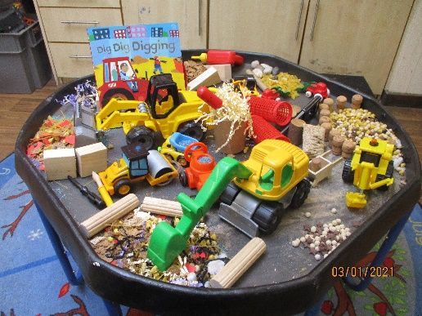
We have had diggers, dragons, knights, princesses and castles,
the pirate ship and the dolls house. I wonder what the
next exciting theme will be?

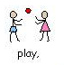
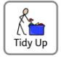
You can play with anything but when you have finished, the things must be put away. Can you practise at home?

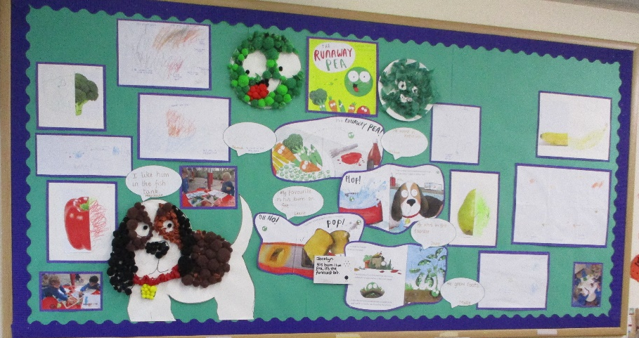

Our learning this half term is all about growing.
Do you like our new Runaway Pea display?

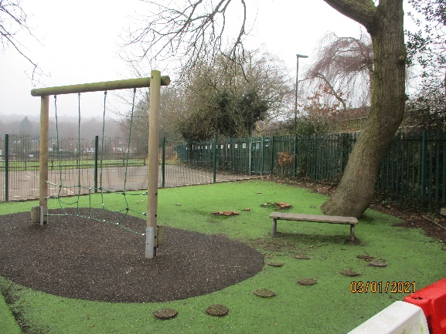
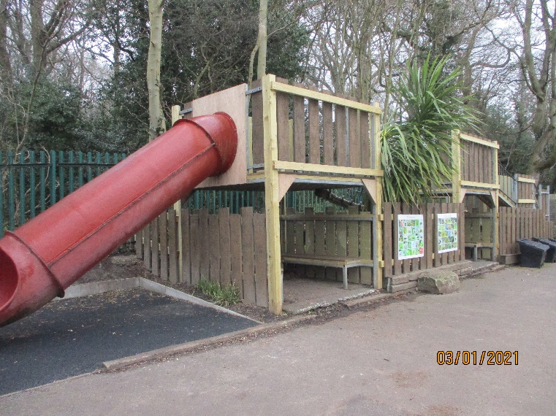
We can still play outside on the top yard with our friends. You can use the slide and play on the trim trail too.

We can’t wait to see you!

