Come to the dobcroft summer fair!
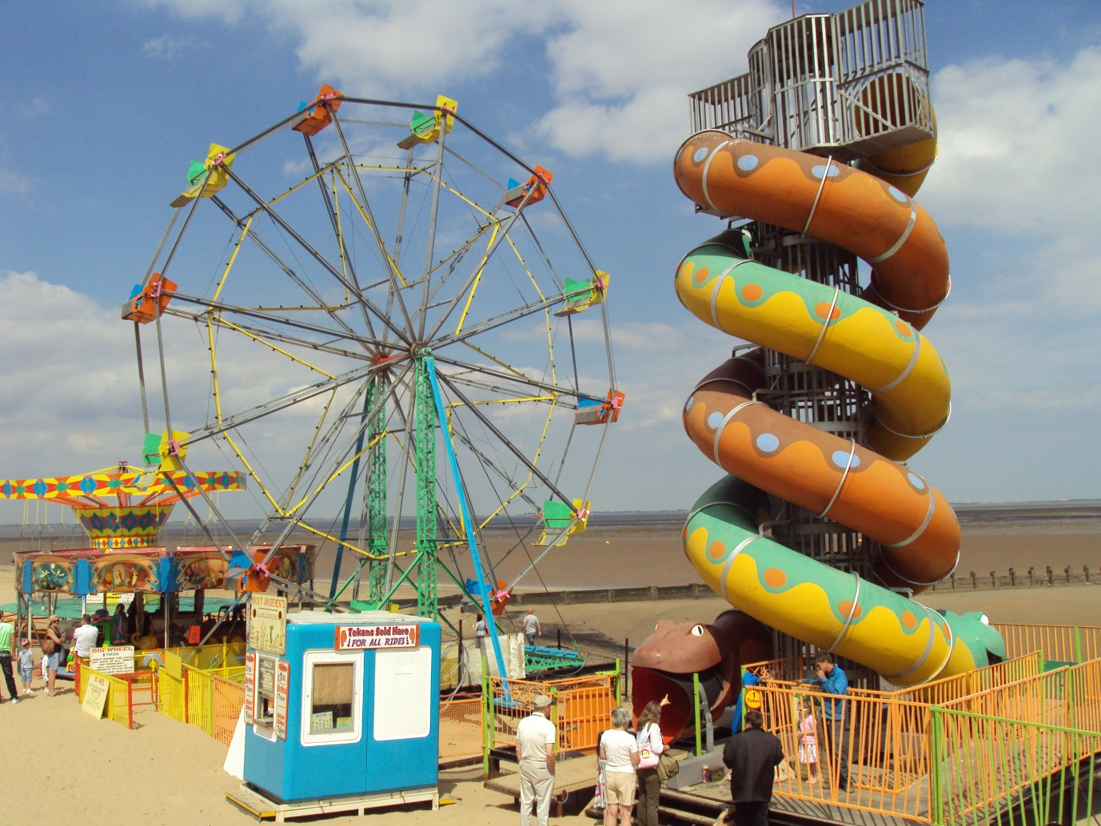
Saturday 1st july 12pm until 4pm

Harry isaac

