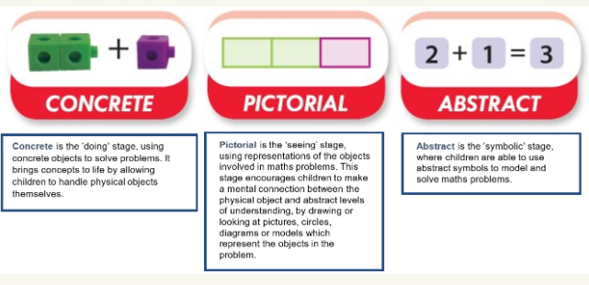

At Dobcroft Infant School, we follow a mastery approach. Children are exposed to the same skill in their maths lessons. Those who benefit from further support may access the activity with additional scaffolding, whilst still working to develop their understanding of the same skill.
Scaffolding is when learning is broken up into more manageable ‘chunks’, and a resource, picture, or additional teaching are accessible to ensure that children develop their conceptual understanding of each key skill. At Dobcroft, scaffolding may take one of many forms, some of which are listed below;
- Pre-teaching vocabulary before the lesson so that children understand when it is used in whole class teaching.
- Staff modelling the activity so that children can see exactly what they need to do in a visual way before they have a go themselves.
- Talking about prior knowledge. What do we know already that can help us here?
- Allowing time for processing the new skill, and to talk through their understanding with peers or an adult.
- Using resources to support children to visually represent their ideas, such as unifix cubes, dienes rods, compare bears, numicon, etc.

How might this be seen in lessons?
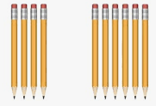
In the following addition activity, children have been asked to match the visual representations to the equations, and to talk about their understanding by justifying their choices.
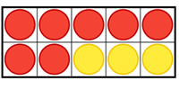




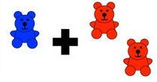
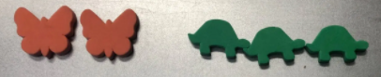

3 + 5 = 8 8 + 3 = 10 2 + 1 = 3 2 + 3 = 5
8 + 1 = 9 2 + 2= 4 6 + 4 = 10
In the second version, the task has been scaffolded by reducing the number of representations given, and by offering some completed matches. This reduces the demand of the task and allows children to focus on conceptual understanding.
3 + 5 = 8 8 + 1 = 9

2 + 1 = 3 3 + 2 = 5 2 + 2 = 4

