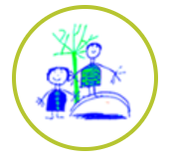
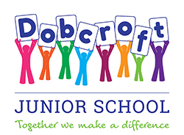
Emotional Health and Wellbeing at Dobcroft: Our Offer to Children and Families

Across Dobcroft Infant and Dobcroft Junior Schools, we are passionate about providing high quality provision to support our children (and families) in their emotional health and wellbeing. We have a joint approach across our two schools in order to offer a core and consistent foundation. In addition to the core offer, we also have a layer of separate, individual provision in order to capture the needs of our bespoke cohorts (see page 2). This two-page document provides an overview of wellbeing provision from whole school approaches to more bespoke, targeted provision.
Dobcroft Junior School - Meet our inclusion team
Mrs Sexton-designated safeguarding leader   |   Mrs Doyle- designated safeguarding leader and senior mental health lead |  |   Ms Little - Special Educational Needs Coordinator (SENDCo) |  | Mrs Fear- Pastoral support  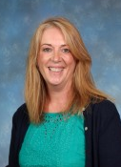 |  |  | Miss Jones- Pastoral & Family liaison Lead and deputy safeguarding lead
Dobcroft Infant School - Meet our inclusion team
Mrs Rowland- designated safeguarding lead  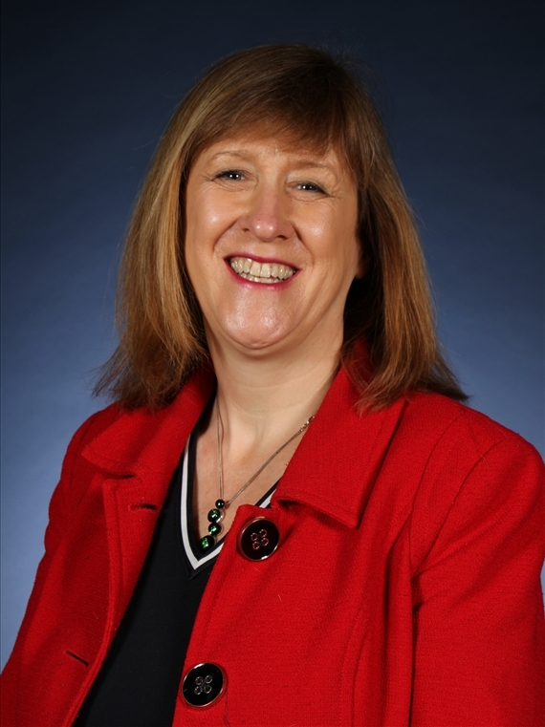 |  | Mrs Singh- deputy safeguarding lead  (starting Jan 2023) / senior mental health lead   |  | Mrs Holmes - Special Educational Needs coordinator / deputy safeguarding lead   |  |  | Harry Jenkinson / Educational Mental Health Practitioner  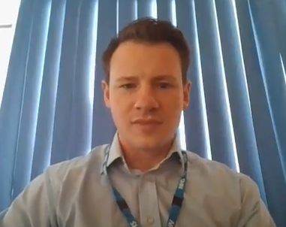
Whole school provision across both Dobcroft Junior and Infant Schools |  |  |  |  |  | Targeted and individual provision offered across both Schools
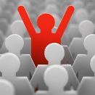We have a senior mental health leader in each school.  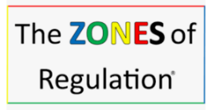  We check in with pupils twice daily, using ‘colour language’ (this is in the Butterfly Room at the Infant school) to describe feelings so that we can support and intervene at the right moment. This system is called the Zones of Regulation and is visible in each classroom.  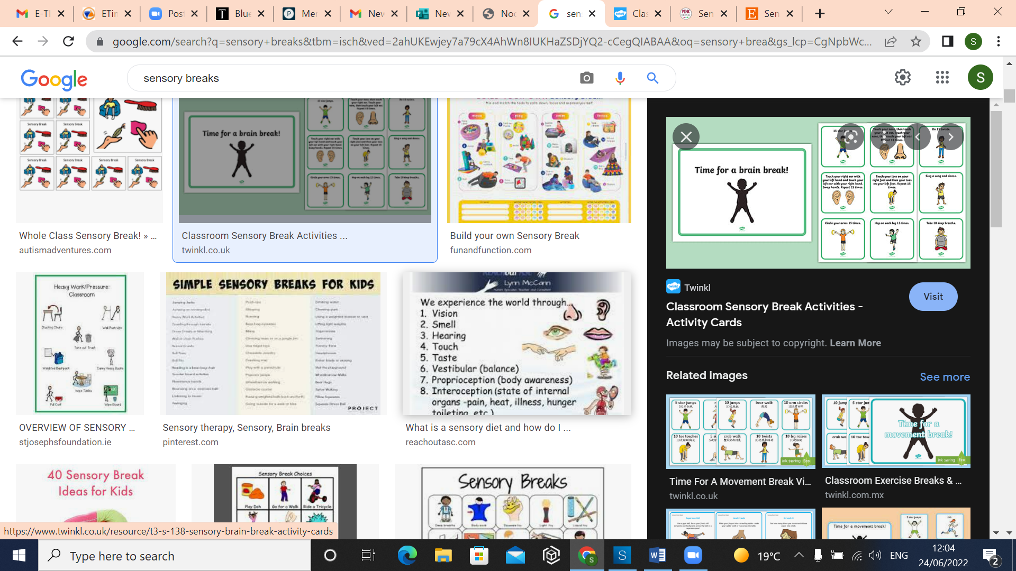  Sensory / movement breaks are embedded into our practice in order to help children get back into their ‘green’ zone and be ready for learning.  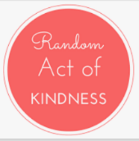  We place high emphasis on kindness and have kindness awards.  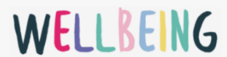We have wellbeing representatives who meet together and drive initiatives to help keep school happy and safe.  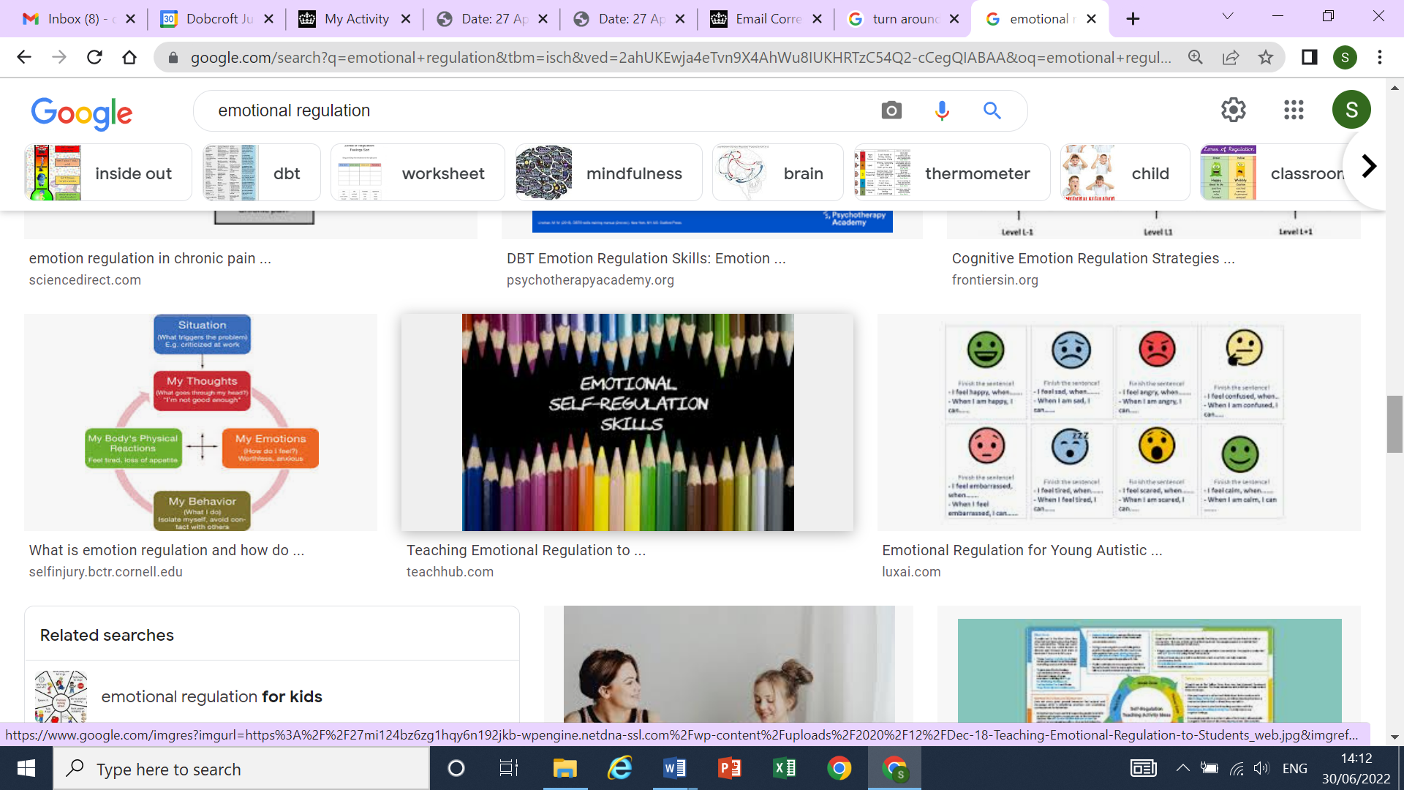  We want children to be able to emotionally regulate as independently as possible so we dedicate an area of the classroom to this. We call it our ‘turnaround’ area. |  |  |  |  |  | 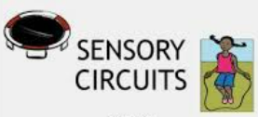  Some children need to physically get ready to learn. We invite children to sensory circuits (at the start of the school day) if we feel that it would support them.  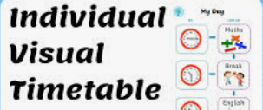  Some children require a bespoke timetable  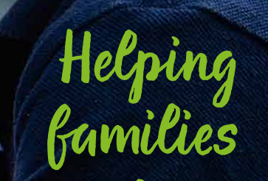  We offer social / friendship groups where dynamics need support and guidance  Sheffield has a Multi-Agency Support Team (MAST) who can support families with a range of challenges. School can support in the referral process.  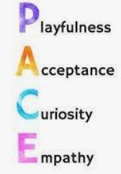  We run pastoral and wellbeing sessions with small groups or individual children. Our approach is led by ‘trauma informed’ practice. The approach is ‘PACE’.

Dobcroft Junior School – What is our school approach to wellbeing?
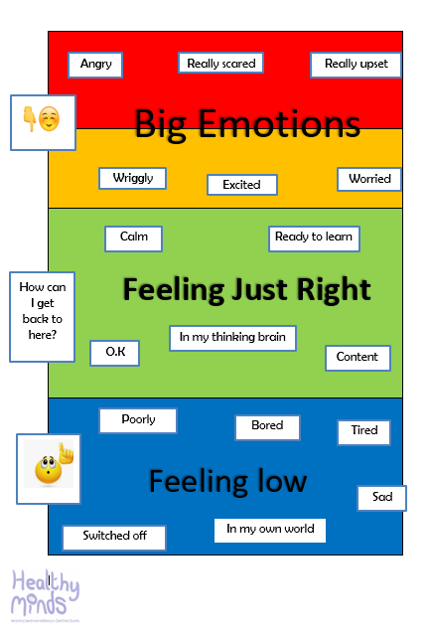
We believe that all behavior is a form of communication and we also know that all children require support and encouragement to navigate through their childhood, being more able to identify and respond to their own feelings and emotions. We base much of our emotion work around the Zones of Regulation, which supports children to be able to identify what they are feeling and importantly, how to use strategies to overcome those moments. Our long term aim for our children is to have successful strategies to provide a strong foundation for positive mental health throughout their lives.

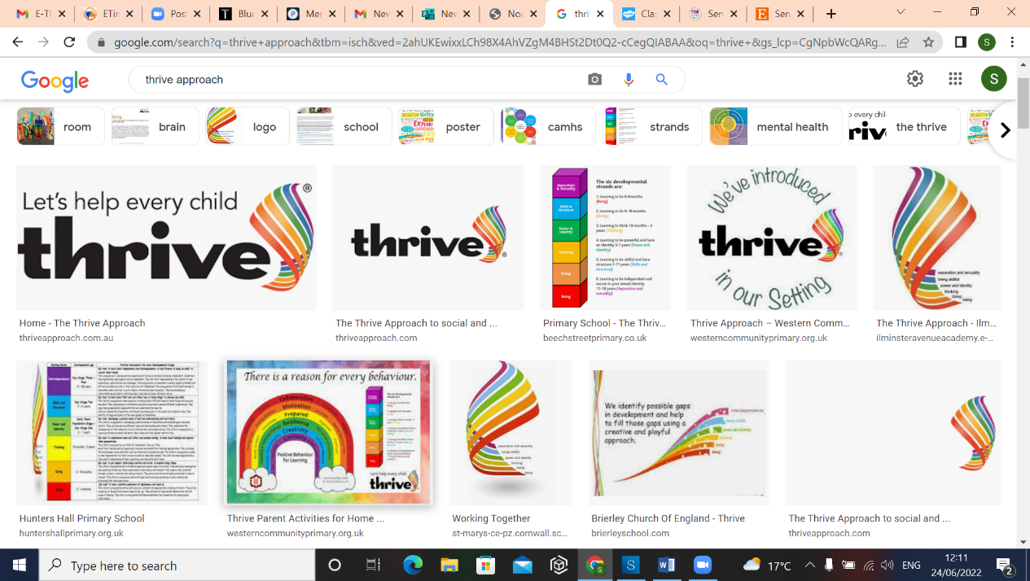
We have also introduced the Thrive approach which is a whole school approach to wellbeing with the aim of supporting our children to become more emotionally resilient and better placed to engage with life and learning. Using the Thrive assessment tool, we capture individual and whole class needs for our entire cohort. With our assessment information, we aim to identify possible gaps in development / learning and help to repair and fill those gaps using a playful and creative approach.

There are three ‘waves’ of provision:
Wave 1: Whole school Thrive provision – every class teacher assesses the class needs and prioritises the key gaps in development for the class as a whole. We have class action plans.
Wave 2: Targeted Thrive provision– Based on assessments, we form Thrive interventions groups of around four children. These groups are short (approximately 20 minutes, twice weekly) and focused around playfully addressing the identified gaps in development. If your child is selected to attend a group, we will be in touch to let you know.
Wave 3: Individual Thrive provision – Some children have very specific gaps in development which is more suited to 1:1 pastoral work, rooted in the science behind Thrive (emotionally available adults being playful and curious, helping children to focus on their specific areas of development), and if so, we will communicate our plans with you.
Dobcroft Junior School - Whole school provision | Dobcroft Junior School - Targeted and Individual provision offered
In addition to the joint school core offer (detailed on page1), at Dobcroft Junior School we also have:  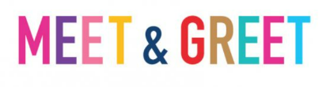  We know that the start of the day is crucial for our children. At Dobcroft Junior School, we ensure that we have members of the inclusion team available to welcome children through the gates and provide support if needed. If your child worries about separating from you or has wider challenges and needs some support as they arrive in school, Miss Jones will be by the DASH gate ready to help, with some calming activities on hand. When entering the classroom, teachers ensure a warm and individual greeting is provided to each child.  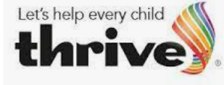  We have a whole school approach to wellbeing (see above)    We have a strong ‘personal education’ curriculum, which comprises of personal, social, emotional and health education alongside relationship and online safety.  We have a ‘Chat Book’ in every class for children to offer their feelings privately, in written from.  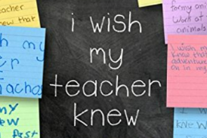  Each term, our pupils submit ‘I wish my teacher knew’ statements so that they have an additional opportunity to privately express anything pertinent to them.  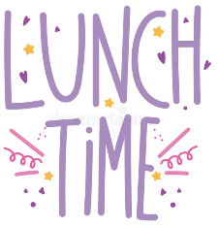  Lunch times can be the best time of day for so many children but can also be a tricky time in terms of emotional wellbeing. We know that children are at their best when they are sufficiently occupied and well supported. To best meet their needs, we have created lunchtime provision that is varied (with a termly ‘menu’) and engaging. Your child will find a wide variety of activities led by play leaders, from scooters to den building and lots more. Children have the opportunity to play alongside others and develop relationships in a supportive setting each lunchtime. | - Targeted Thrive groups / 1:1 sessions with a Thrive practitioner.  - Pastoral support at 1:1 level with a pastoral support plan.  - Small group targeted intervention e.g. a friendship group  - A learning mentor, Miss Jones, as well as our pastoral worker, Mrs. Fear, available for children who may need support in order to regulate.  - Individual lunchtime plan / structure where needed so that children have a more successful lunchtime.  - Inside spaces offered at lunchtime. We have a room called ‘5 minutes peace’ where children can go to regulate and have a calm environment with an adult on hand.  - ‘One Page Profile’ summary document detailing a child’s views and specific needs in terms of support. This is available for all staff so that we all have that understanding.  - Individual behaviour plans where our whole school behavior policy is not appropriate.  - Team around the Family meetings to bring together all professionals to work as a team to target a specific concern.

Dobcroft Infant School – What is our school approach to wellbeing?
At Dobcroft Infant School, we are committed to supporting the emotional health and wellbeing of our pupils and staff and community.
We have a supportive and caring ethos and our approach is respectful and kind, where each individual and contribution is valued.
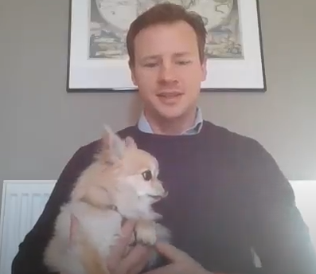
At our school we know that everyone experiences life challenges that can make us vulnerable and at times, anyone may need additional emotional support. We take the view that positive mental health is everybody’s business and that we all have a role to play. We have a fantastic Mental Health practitioner (EMHP), who supports the school 1 day a week. He uses CBT techniques and teaches the children how to manage many of the emotions that they feel.
At our school we:
Help children to understand their emotions and feelings better - with the support of Harry our EMHP
Help children feel comfortable sharing any concerns or worries with trusted adults.
Help children socially to form and maintain relationships.
Promote self esteem and ensure children know that they matter and have strengths and things that they may find trickier.
Encourage children to be confident and ‘dare to be different’ but understand that we are all equal.
Help children to develop emotional resilience and to manage setbacks.

We are a Healthy Minds School and teach the children to understand and manage their emotions.

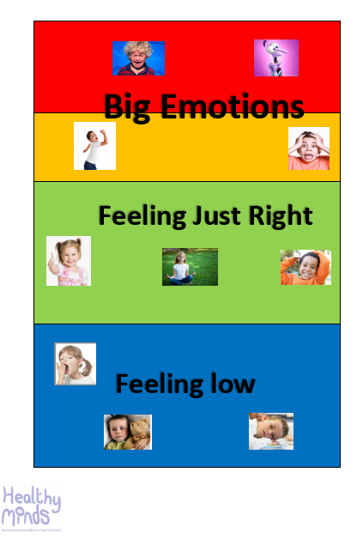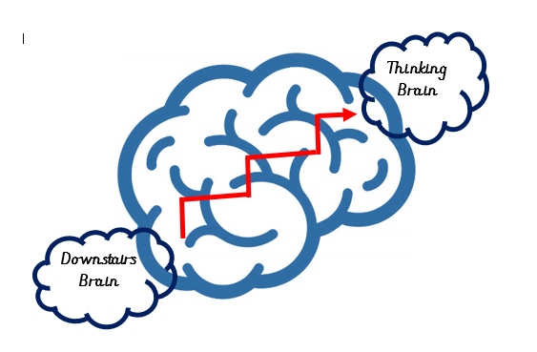

Dobcroft Infant School - Whole school provision | Dobcroft Infant School - Targeted and Individual provision offered
  In addition to the joint school core offer (detailed on page1), at Dobcroft Junior School we also have:  Targeted meet and greet for those children/ parents who may need some support with the home/ school transition. This may be due to a mental health need or medical need.  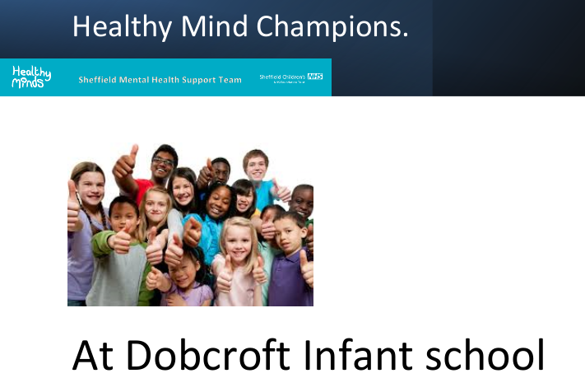  We have a team of healthy minds champions from Y2, they are trained by our EMHP and the Deputy Head to support their peers when they fall out. They wear green caps and go out on the playground with calming down tricks to support the other children.. They hold regular assemblies which focus on different emotions.  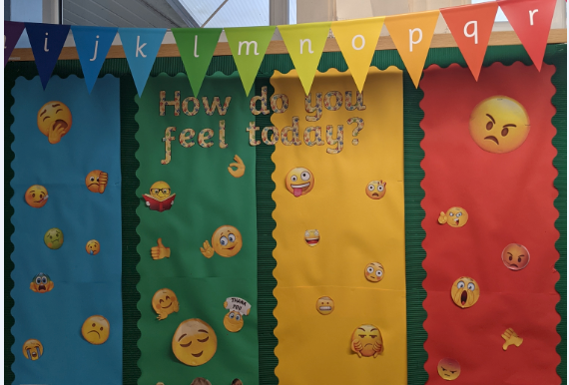  We have a comprehensive ‘RSE’ curriculum, which comprises personal; social, emotional and health education alongside relationship and online safety. We constantly check in with our children to check how they are feeling.    Each class has a worry monster, where if a child has a worry, they post either their name, or their worry into the worry monster's mouth. The teacher can then talk to the child, or the class about the worry if needed.  In nursery if a child is feeling a little worried they can have a hug with the worry monsters and this can also let the teacher know that they are not feeling in the “green zone”  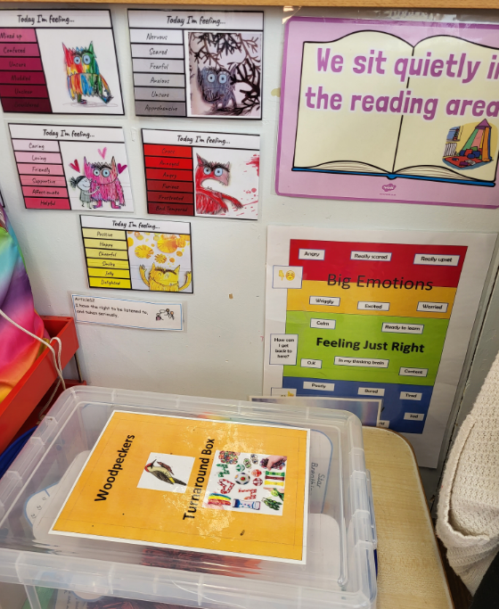  Turn around boxes are located in every classroom, if a child is feeling dysregulated they can take a fidget toy from the turn around box to help them to get back to the green zone and their thinking brain. Children love to use these resources and are proud to show them off to their parents.  Each class in KS1, has a put it right area where children can come and put right their conflicts. There are calming down tricks, seats for them to sit on and support if they need it. | - SUpport for children in our inclusion room (The Butterfly Room)  - Pastoral support for both children and parents with our EMHP  - Social groups in the early years to establish those early friendships  - AN EMHP, the Butterfly Staff and the team in the Hive, all there to support children to manage their emotions.  - Fine dining club in the Butterfly room for all the children who struggle at lunchtime or need that extra space.  - The Butterfly Room also provides support for those children who find the playground too difficult to manage.  - ‘One Page Profile’, which is the child’s voice; which they then choose the layout and design of.  - Support plans which set out who to support the child, these are designed with parents during our SEND meetings.  - Team around the Family meetings to bring together all professionals to work as a team to target a specific concern.  - MAST support workers in once a term to support parents who may be finding mental health barriers, e.g. with sleep or behavior.

