‘To provide a foundation for fulfilled lives, inspiring confident and happy learners’
Enjoy learning | Try our best | Make good choices | Respect each other & our surroundings | Work together | Celebrate our successes
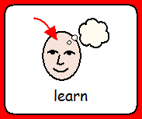 | 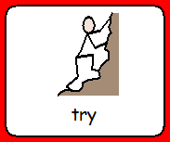 | 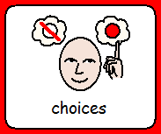 | 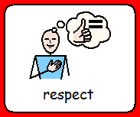 | 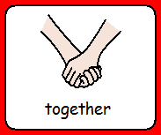 | 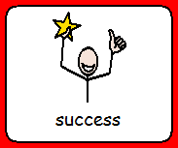

Dobcroft Infant School
The English Curriculum
A high-quality education in English will teach pupils to speak and write fluently so that they can communicate their ideas and emotions to others and through their reading and listening, others can communicate with them. All the skills of language are essential to participating fully as a member of society; pupils, therefore develop these skills throughout their time at Dobcroft Infant School through speaking and listening, reading and writing on a daily basis.
The overarching aim for English in the national curriculum is to promote high standards of language and literacy by equipping pupils with a strong command of the spoken and written word, and to develop their love of literature through widespread reading for enjoyment. We therefore focus on these 4 main areas when teaching English:

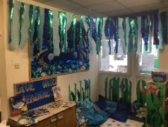
- Spoken language – Children learn to speak clearly, thinking about the needs of their audience (listeners). This is practised through the development of ‘Show and Tell’, drama and presentations for the class or wider school during assembly. ‘Time to Talk’ is an initiative used throughout the school to enable pupils to participate in and develop conversational skills as well as being encouraged to develop a capacity to explain their understanding of books and other reading, and to prepare their ideas before they write.

- Reading – Children’s interest and pleasure in reading is developed as they learn to become fluent, confident independent readers. Children learn the skills of decoding and word recognition within texts as well as developing the comprehension and meanings alongside this. Skilled word reading involves both the speedy working out of the pronunciation of familiar and unfamiliar printed words. Phonics is therefore emphasised in the early teaching of reading to beginners when they start school. Children will develop their understanding and love for text through discussing a range of stories, poems and non-fiction.

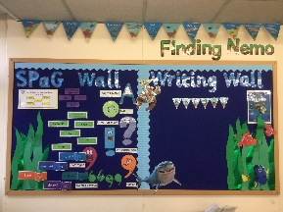
- Writing – Children are encouraged to develop competence in both transcription and composition. The children need to see the value in their own writing through planning, revising and evaluating their own work. Children learn to communicate meaning in narrative, non-fiction and poetry texts.
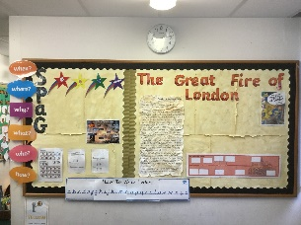

- Spelling, punctuation and grammar (SPaG) – Enhancement of pupils’ vocabulary arises naturally from the opportunities created in their reading and writing. It is important that pupils learn the correct grammatical terms in English and use these concepts to feed into their independent writing. Correct spelling are to be used for common exception words and phonetically plausible attempts used for more complicated word choices.
How is English taught at Dobcroft Infant School?
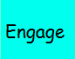
English is taught in an engaging and contextual way throughout school, where all children are given plenty of opportunities to develop their SPaG skills as well as their creative writing. The carefully planned mastery approach to the English curriculum enables all children to succeed, with many pupils exploring concepts in different contexts for greater depth. Reading and writing are closely linked by using the same class text in both guided reading and writing lessons.
Writing is taught as a six part lesson;
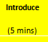
Engage
Introduce
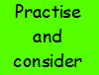
Practice and consider
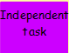
Independent task
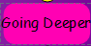
Going deeper
Review and improve
We also encourage children to develop their confidence, resilience, and ability to tackle a range of genres over their time at the school. Children are taught songs and rhymes, use oral rehearsal and talk for writing. We follow a 2/3 week unit of learning based on a class text with a specific genre. This class text is shared with the children at story time (EYFS and Y1) or during guided reading lessons (Y2) to ensure a whole reading and writing linked approach. The unit consists of showing the children a WAGOLL (what a good one looks like), pulling the features of this apart, learning the SPaG (spelling, punctuation and grammar) skills they will need to apply, planning and creating their own version. Learning will then be revisited in different genres and built upon to ensure that children are given the opportunity to consolidate understanding and develop a level of fluency in their learning in a variety of writing texts over time.

Foundation Year

- Every child works with the teacher in writing every week in a 1-1 or a small focus group session.
- 1:1 reading with a teacher occurs every week with daily opportunities built in to read every day in the classroom to consolidate decoding skills alongside comprehension.
- A phonics area in the classroom allows children to practise the phonetic skills independently.
- A writing area in the classroom allows children to apply their recording skills independently.
- English is woven into every part of the day – links to reading, spelling and idea generation.
- Real life experiences and shared ‘big books’ are the stimulus for writing in the EYFS.

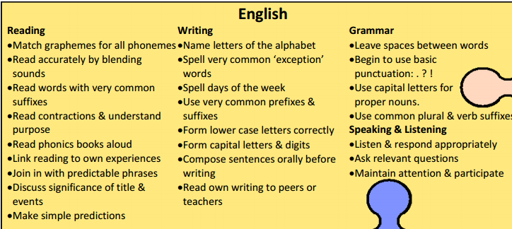
Objectives for Y1

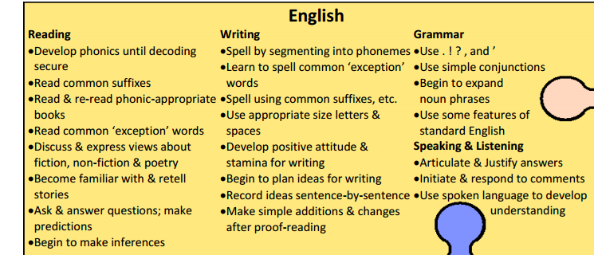
Objectives for Y2

English and Inclusion
All children will have access to the English curriculum regardless of ability, gender and race. The whole School Policy on Equal Opportunities will apply through the English curriculum. Pupils of all abilities will be taught with their own class. Their thinking will be supported or extended through targeted questioning and differentiated work which will allow for the development reading and writing at children’s own level.
How can you help at home?
Homework will sometimes be set to support their growing independence in longer pieces of writing.
Daily reading at home for 10 minutes every day with your child. Focus on phonetic blending, fluency and pace and comprehension to build understanding alongside decoding skills.
Read to your child as well as them reading to you. Encourage the love of reading and enjoyment of stories. Reading a bed time story is a good time for this!
Practice spelling zappers at home. Each year group has their own set of spelling zappers to work through in order.
Talking to your child about creative vocabulary and what new words mean helps them to add these words to their own vocabulary and then in turn include them in their writing.
Visit your class webpage to check for any resources that have been added to help in home learning.

