‘To provide a foundation for fulfilled lives, inspiring confident and happy learners’
Enjoy learning | Try our best | Make good choices | Respect each other & our surroundings | Work together | Celebrate our successes
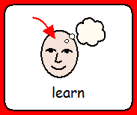 | 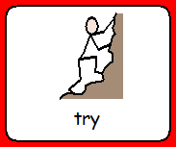 | 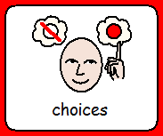 | 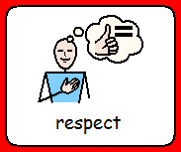 | 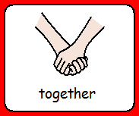 | 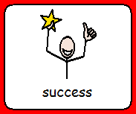

Dobcroft Infant School

The Design and Technology Curriculum

Our vision
At Dobcroft Infant school we believe that design and technology prepares children to become 21st century learners. The creative thinking encourages children to become autonomous and resourceful problem solvers both as individuals and as part of a team. It enables them to identify needs and opportunities and respond by designing ideas and eventually making products fit for purpose.
In FS2, Design and Technology planning follows the Early Years Foundation Stage guidance as part of the Expressive Arts and Design area of learning. In KS1, we follow the learning objectives as set out in the National Curriculum. Across our school, Design and Technology is often linked to the termly topic of each year group to provide purposeful opportunities for the children.

How is design and Technology taught at Dobcroft Infant School?

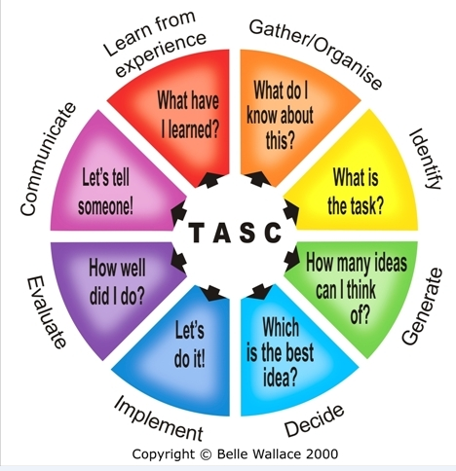
TASC (Thinking Actively in a Social Context) is used throughout the whole school to deliver Design and Technology. The children use the elements of the TASC wheel to support their learning (see picture).

The outdoor provision also supports children’s learning of Design and Technology with access to a ScrapShed and Poddley at break and lunch times as well as construction materials available in the continuous provision both inside and out.

Foundation Stage 2

In this area of development, children will understand how to manipulate materials to achieve planned effects, construct with a purpose in mind, using a variety of resources and use simple tools and techniques to assemble and join materials appropriately and safely. These skills will be applied to designing and making Christmas decorations, sock puppets and an object to help Gingerbread Man cross a river.

Key Stage 1

In this key stage, children are taught key skills that are then applied in meaningful contexts. In both year groups, food technology is taught and children use the basics principles of a healthy and varied diet to prepare dishes and understand where food comes from.
In Year 1, children design functional products for themselves, select and use a range of tools to perform practical tasks such as cutting and joining, explore and evaluate existing products, build structures, exploring how they can be made stronger, sturdier and more stable.
In Year 2, children build on these skills to design purposeful appealing products based on design criteria. They generate and communicate their ideas through drawing and templates, select and use a range of materials including construction, textiles and ingredients according to their characteristics, evaluate their ideas and products against the design criteria and explore and use mechanisms such as levers, sliders, wheels and axles.

How can you help at home?

- Practise skills such as cutting, hole punching, etc…
- Use different ways of joining materials together such as using tape, split pins, treasury tags, etc…
- Practise sewing skills to join fabrics.
- Design models and then build them using construction kits or junk modelling.
- Evaluate models and think of ways in which they can be improved.

