‘To provide a foundation for fulfilled lives, inspiring confident and happy learners’
Enjoy learning | Try our best | Make good choices | Respect each other & our surroundings | Work together | Celebrate our successes
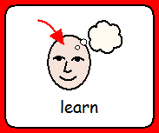 | 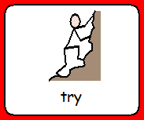 | 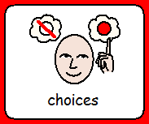 |  | 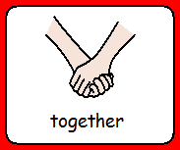 | 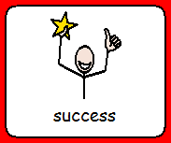

Dobcroft Infant School

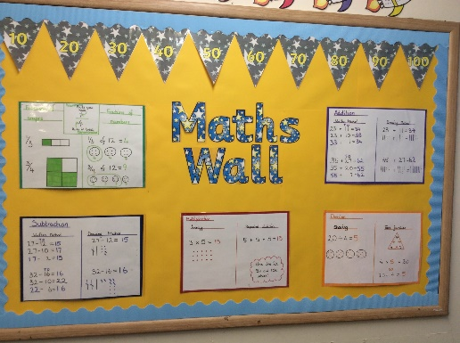
The Maths Curriculum
We use the National Curriculum for Mathematics as a scaffold for planning children’s learning. We have adopted a Mathematics Mastery approach, where children explore key concepts in detail, using concrete apparatus and pictorial representations to support their learning. Once a strong foundation and understanding of these key skills has been developed, children then link this to a variety of carefully planned abstract concepts. All children will have access to the Numeracy curriculum regardless of ability, gender and race. The whole School Policy on Equal Opportunities will apply through the Numeracy curriculum. Pupils of all abilities will be taught with their own class where appropriate and scaffolding by the class teacher will ensure that all pupils will reach their maximum potential.

How is Maths taught at Dobcroft Infant School?
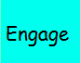
Mathematics is taught in an engaging and practical way throughout school, where all children are given plenty of opportunities to engage with reasoning and problem solving activities. The carefully planned mastery approach to the mathematics curriculum enables all children to succeed, with many pupils exploring concepts in greater depth.
Numeracy is taught as a six part lesson;
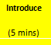
Engage
Introduce
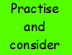
Practice and consider
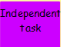
Independent task
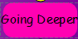
Going deeper
Review and improve
We also encourage children to develop their confidence, resilience, and ability to tackle a range of mathematical problems which are represented in different ways. Children are taught songs and rhymes during daily ‘Maths Moments’ to help them to remember and recall key maths facts. Learning will be revisited often to ensure that children are given the opportunity to consolidate understanding and develop a level of fluency in their learning.
Children are taught star words to support the development of mathematical language. Here is an example of our star words:-
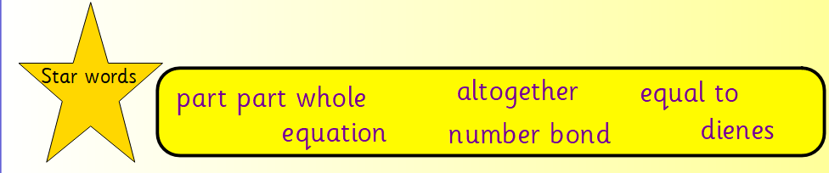

What’s happening in the Foundation Year

- Every child works with the teacher in Maths every week in a 1-1 or a small focus group session
- Maths moments every day reinforce key concepts and basic mental maths skills
- A maths area in the class room allows children to work with maths equipment independently.
- Maths is woven into every part of the day – register and lunch orders, counting songs and rhymes, ordering activities, jigsaw puzzles, and games
- A Mud Kitchen and the large scale loose parts offer on-going opportunities for the development of mathematical concepts and language, alongside collaboration, problem solving, and spatial awareness.

Objectives. for Y1
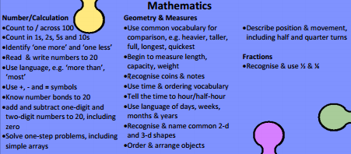
Objectives for Y2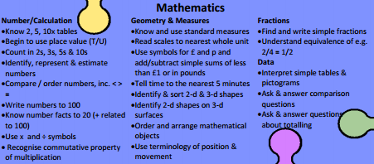

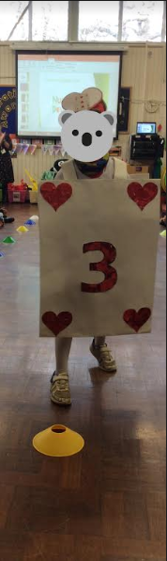
How can you help at home?
Homework will sometimes be set to support their growing mathematical understanding.
Every day activities are filled with opportunities to learn maths! Make children see maths is relevant to everyday life and have some maths fun!
Practice counting at home – can they count forwards and backwards as well as starting at different numbers.
Can they count in 2s (count pairs of socks) 5s (Twirls?) 10s
Weigh and measure when helping to bake
Cut food into fractions such as halves and quarters.
Share objects and food between 2, 3 or more people.
Learn to tell the time.
Look for 2D and 3D shapes in the environment
Use money to buy things (I had a pile of play money on the table and use to charge my boys for snacks!)
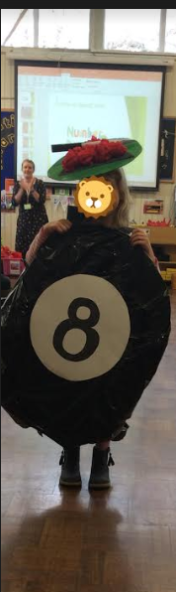
List of Maths Websites for Children
http://amathsdictionaryforkids.com/
http://www.bbc.co.uk/bitesize/ks1/maths/
http://www.bbc.co.uk/bitesize/ks2/maths/
http://www.ictgames.com/resources.html
http://www.ilovemathsgames.com/
http://www.mathsisfun.com/index.htm
http://www.mathszone.co.uk/
http://www.multiplication.com/
http://www.primarygames.co.uk/
http://resources.woodlands-junior.kent.sch.uk/maths
http://www.topmarks.co.uk/

