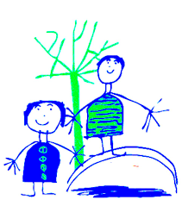
Dobcroft Infant School
At Dobcroft Infant School we aim to provide a
Foundation for fulfilled lives, inspiring confident
and happy learners.

What PE looks like at DIS

Children in Year One and Year Two follow the National Curriculum which is taught through cross curricular themes wherever possible.

This purpose of this booklet is to show you how children learn about PE, and some of the content that they cover during their time at Dobcroft Infant School.

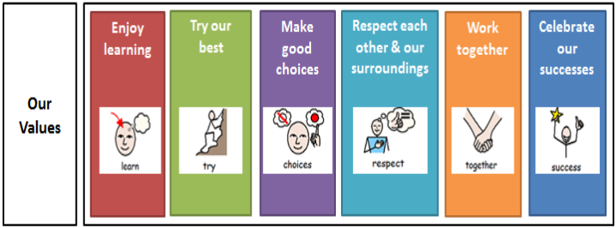

Key content of the PE curriculum:
Children will cover the fundamental skills in PE including running, jumping, throwing, catching, kicking and dribbling. Alongside this children will also be challenged to develop the balance, agility and co-ordination and they will begin to apply these skills into a range of activities.
Lessons will not only aim to develop children’s fundamental skills, but they will also encourage children to participate in team games, developing simple tactics for attacking and defending.
During dance and gymnastics lessons children will develop their ability to perform dances and sequences using simple movement patterns and begin to transfer these skills onto apparatus.

The children will experience PE and develop their skills in a variety forms and activities including:  Gymnastics  Games  Athletics  Dance  Swimming  Skipping  Outdoor activities | At DIS we also strongly believe in promoting active playtimes where children are engaged in physical activity.  What we do at active playtimes:  Football  Podley  Scrap Shed development  Skipping  Parachute Games  Team Games  Soccer-eds

Engaging children in sport at DIS

Children in KS1 attend a range of Sports Festivals and competitions through our links with Points Learning Network.  Year 2 attend the Annual Points Network Games at the incredible English Institute or Sport. This year they competed in a KS1 football competition.  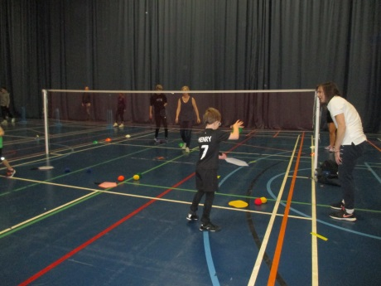 | 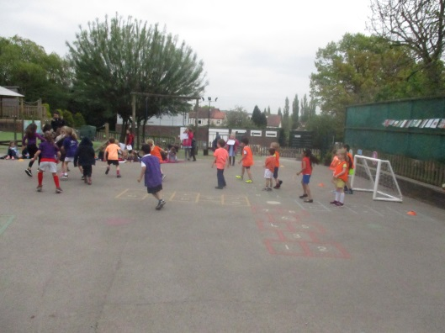  Sporting events through the year. From our sponsored walk, Move More day to a Year 1 football tournament. At DIS we are always seeking new ways to encourage children to be more active and promote sports at school.
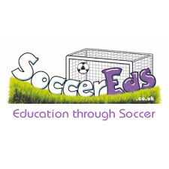  We provide a range of fantastic after school sports clubs that our children really enjoy.    Karate, golf, Razzmatazz and Soccer-eds are just a few examples. | Sports Day –  Each year we have a fantastic day run by the Soccer-eds group where children from FS and KS1 participate in a range of different football, rugby and netball based activities.  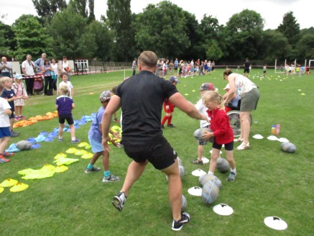

Encouraging children to be active and participate in sport is very important. The latest guidance from the government says that children should be active for at least 60 minutes every day; 30 minutes and home and 30 minutes at school.

How to support children’s learning and love of sport and PE:
- Visiting your local sports / leisure centre
- Join a local club – we have lots of fantastic clubs around us including:
Grove Road Tennis club, Abbeydale Tennis club, Park Tennis at Millhouses Park.
- Supporting a local or national sports team or take your children to a sporting event.
- Support and praise children to be proud of their sporting achievements and share these with your class teacher.
- Inform school of sporting achievements e.g. events taken part in or placed in.
- Engage with one of our after school sports clubs.

How to be active together at home:
- Travel to school in an active way – walk, ride a bike, scooter
- Learn to ride a bike or scooter
- How many hops/jumps can you do in 1 minute?
- Learn to swim
- Make a dance up for your favourite song
- Make an obstacle course in your garden
- Go for a family walk
- Join a sports club / team
- Play football in the garden/park
- Climb a tree
- Have races (running, hopping)
- Talk about sportsmen/women

If you would like any further information on how you can be active as a family there is information on our PE board in the hall. If you wish to know more about local clubs there is information in reception.

