‘To provide a foundation for fulfilled lives, inspiring confident and happy learners’
Enjoy learning | Try our best | Make good choices | Respect each other & our surroundings | Work together | Celebrate our successes
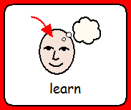 | 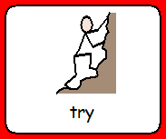 | 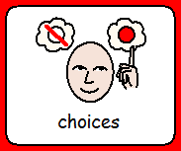 | 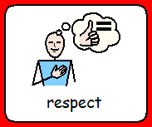 | 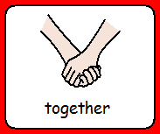 | 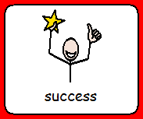
Dobcroft Infant School
Scientists
Create,
Investigate,
Experiment,
Negotiate,
Challenge,
Evaluate
The Science Curriculum
At Dobcroft Infant school we believe that science inspires children, encourages them to be inquisitive about the world. We know that a high quality science education provides the foundations for understanding the world.
Please see the progression map on the school website for more information about the key steps and how we build on prior knowledge.
Foundation stage:
In foundation stage, the children follow the Early Years Foundation Stage (EYFS) curriculum. Science is widely covered as part of the Understanding of the World theme.
Year 1 science
Children will be learning
- Plants, identifying and naming plants and looking at their basic structures.
- Animals including humans, identifying and naming a range of animals and understanding how and why they are grouped (e.g. mammals, birds, amphibians etc).
- Everyday materials, looking at their properties.
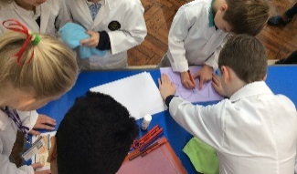
- Seasonal changes, observing changes across the four seasons and looking at different types of weather.
Year 2 science
Children will be learning
- Living things and their habitats, including dependence within habitats and micro-habitats.
- Plants, observing how seeds and bulbs grow into plants and what plants need to stay healthy.
- Animals including humans, focusing on reproduction, nutrition and exercise.
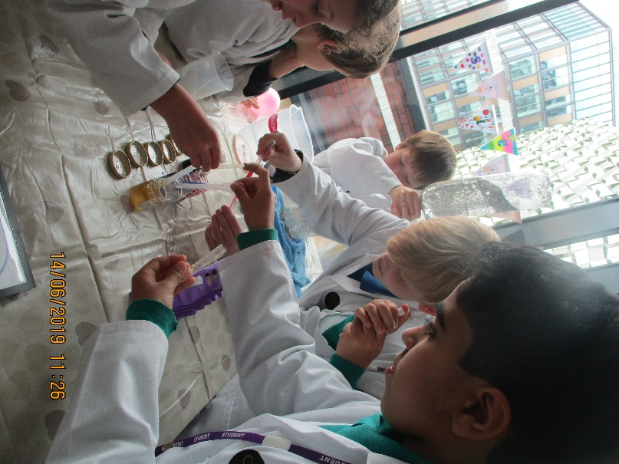
- Everyday materials, comparing their uses and looking at how they can be changed by exerting force.
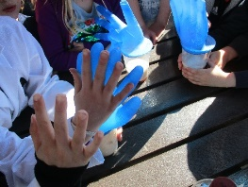

How is Science taught at Dobcroft Infant School?
Foundation
Science is taught each term through exploring and investigating different areas.
Key Stage 1
During Key Stage 1 the children will explore the world around them and raise their own questions this is taught through the following practical scientific methods:
- Asking questions and recognising that they can be answered in different ways.
- Using their observations and ideas to suggest answers to questions.
- Observing closely, using a variety of equipment.
- Performing scientific enquiries/tests.
- Identifying and classifying.
- Gathering and recording data to help answer questions.
The curriculum in foundation and Key stage 1 is also supported through extra curriculum activities within school, such as science after school clubs and local trips. We also have Year 2 science ambassadors that assist teachers and children with science around school, promote science to others, and demonstrate experiences in assemblies and to their peers in the Science lunchtime club. Occasionally, they attend outreach events such as the Science Ambassador’s Conference at Sheffield Hallam University. This project has been funded by the Ogden Trust, with whom we are working closely as a school and as part of a partnership of local schools.
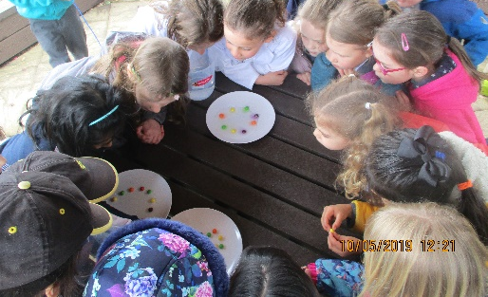
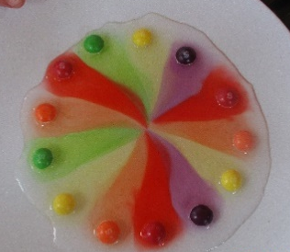

How can you help at home?
- Visit your class blog for our half termly knowledge organiser. This contains the key learning along with all the key knowledge and vocabulary.
- Collect interesting objects and group them in different ways.
- Carry out your own investigations. Can you explain your findings?
- Use of questions to extend your child’s learning.
- Plant fruit and vegetables and observe them grow.
- Visit Dobcroft Infant School twitter page for loads more information.

Have fun exploring the Science around you!
