Year 2 RHE Knowledge Organiser
Autumn 1
Theme: Community
 | Key Knowledge | Key Vocabulary
 | By the end of this unit pupils will…  Be able to name different communities and talk about the communities they belong to. These might include the school community, Sheffield community or a place of worship.  The children will also be able to talk about different cultures and say how these can vary in terms of language, food, music and religion. The children will recognise differences in values and understand the need for respect.  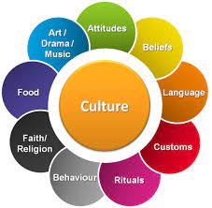  The children will begin to look beyond their immediate community and be able to talk about the benefits of being a global citizen.  CRC Article 19: All children have the right to be safe.  CRC Article 12: All children have the right to learn
  Respect | Accept somebody for who they are even if you don’t agree
  Culture | The beliefs and behaviours practised by a group of people.
  Religion | What you believe about.
  Celebrations | When you do something special for an important event.
  Traditions | Handing down information in your family.
 |  | Local Links / Exciting Books/Associated Trips
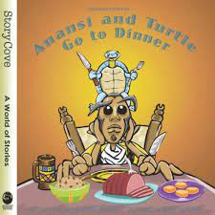
Anansi and the Turtle go to Dinner
by Bobby and Sherry Norfolk
Talk about your own culture
and culture of your family.

