Year 1 RHE Knowledge Organiser
Autumn 1
Theme: Community
 | Key Knowledge | Key Vocabulary
 | By the end of this unit pupils will…  Understand what it means to be part of a community and what it means to be part of the wider school community. The children will be able to name the class they belong to and the people in school that are special to them.  The children will learn the school values are and why we need these in place. The children will be able to say how they should behave in school and identify good and bad behaviour choices. They will also be able to say how we can make improvements to make school an even happier place.  Our School Values  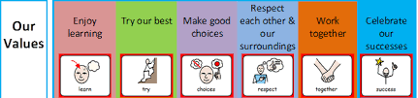  Can you remember all six values?  CRC Article 19: All children have the right to be safe.  CRC Article 12: All children have the right to have their  opinions valued.  CRC Article 24: All children have the right to a clean environment.
  Community | A group of people living in the same place or having something in common.
  Belonging | Having a relationship or connection with a group of people.
  Rules | A set of instructions to help people live and work together.
  Values | How we think and how we act
  Behaviour | How somebody acts.
  Feelings | Somethings we feel inside ourselves.
 |  | Exciting Books and things to do at home
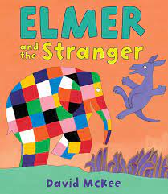
Read Elmer and the Stranger By David Mckee.
Talk about your home community.
Think about the rules we have to follow in
everyday life.

