FS1 |  | FS2
Counting / number sense  - Verbally count to 10  - Count out up to 5 objects or actions  - Understand the sequence of numbers up to 5  - Subitise up to 4  - Recognise representations of numbers up to 5 including numerals  - Explore the composition of numbers to 5  - Compare an amount of objects; use vocabulary more and fewer, same/equal to | 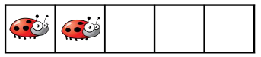      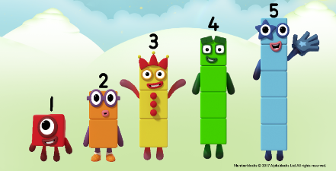 | Counting / number sense  - Verbally count to 20  - Count out up to 10 objects or actions  - Understand the sequence of numbers up to 10  - Subitise up to 5/6  - Recognise representations of numbers to 10 including numerals  - Recognise and order numerals to 20  - Compare sets of objects up to 10; use language of more/fewer/equal to  - Explore patterns of numbers up to 10 including odds and evens, and counting in 2s and 10s  - Recall number bonds to 5, and some bonds to 10  - Recall doubles up to 5+5  - Represent numbers in a variety of ways including block graphs, pictograms and tally charts. | 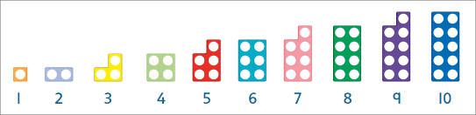  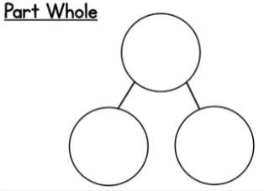
Adding/subtracting  - Begin to explore the composition of numbers to 5  - Begin to find the total number of objects in 2 groups by counting them all  - Differentiate between whole objects and parts of an object.  - Say how they know whether something is a part of an object or a whole object. | 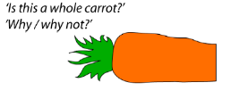  Putting objects into groups (introduction to two parts)    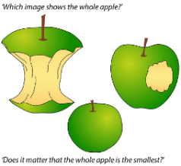 | Adding/subtracting  - Begin to read and understand equations.  - Understand and use the symbols + and =  - Begin to use the symbol -  - Solve addition and subtraction equations using concrete, pictorial or abstract methods as appropriate  - Represent equations in different ways, e.g. using number lines with missing numbers, or blank  - Using a hundred square to support understanding where appropriate  - Articulate their understanding and reasoning to an adult or peers | 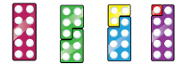  “I know this because…”  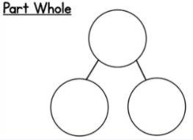
Geometry  - Recognise, name and match colours  - Sort objects by size, colour, type and talk about why they have grouped them this way  - Continue AB and ABC repeating patterns  - Begin to create their own AB repeating patterns  - Talk about the properties of shapes in the environment e.g. straight, smooth, round  - Begin to name 2D shapes (circle, square, rectangle, triangle) | 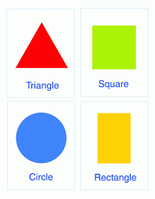     | Geometry  - Sort objects by various attributes and explain their reasoning  - Copy, continue and create AABB, ABB, and AAB patterns.  - Name 2D (square, rectangle, circle, triangle, hexagon) and 3D shapes (cube, cuboid, sphere, cone, cylinder) and describe their properties (sides and faces) | 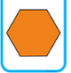  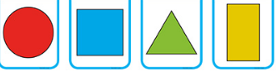  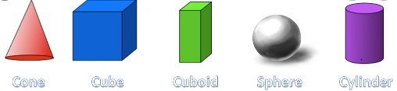  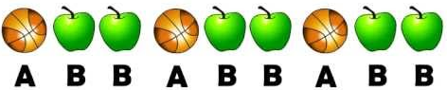  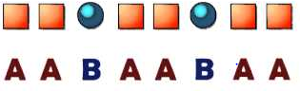
Measures  - Use the language of size, length and height  - Compare 2 objects and use the language bigger/smaller, longer/shorter, taller/shorter  - Talk about the order of their day  - Use the language of light and heavy  - Compare 2 objects by their weight  - Use the language of full, half full empty  - Use the positional language of in, on, under, up, down, across, in front of, behind, on top of | 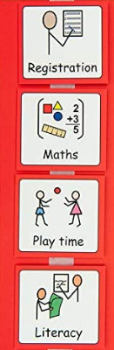  We do the our maths learning and then it’s playtime.  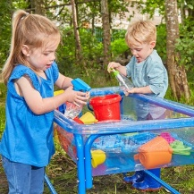  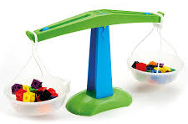   | Measures  - Compare and order 3 objects by size, length, height  - Use non-standard units of measurement for length  - Order their day using the language first, next, last.  - Order the days of the week and months of the year.  - Use the language light, heavy, balanced and order 3 objects by weight  - Use the language full, nearly full, half full, nearly empty, empty  - Compare and order 3 containers of liquid by their capacity  - Use the language forward, backwards, left, right, in between, next to | First it’s register, next is maths and after that it’s play time. We do literacy last.  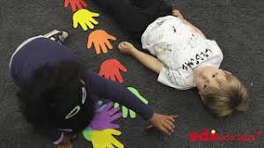    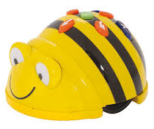  “The x is the heaviest. I know this because…”

