Pupil Premium Strategy 2020/21
School Vision
At Fulfen Primary School every child is important. We want your child’s time at Fulfen to be a positive experience and hope they look back on their time here as a happy one. High self-esteem is encouraged, high expectations, standards and values are fostered and progress and achievement are positively monitored and celebrated.

Fulfen has many good qualities, the most important of these being a dedicated and caring staff who share a wealth of experience, in addition, we have excellent facilities in a beautiful setting and enjoy support from the local community. In certainly is an exciting time here at Fulfen where new initiatives are having a very positive impact on standards. In partnership with parents and carers, we strive to ensure academic success and develop personal qualities in pupils of which we can be proud.

We strive to make our curriculum exciting, challenging and engaging and encourage children to be independent learners. We aim to provide every opportunity for children to apply English, Mathematics and Information technology skills across their learning in addition to collaborative group work and presentation skills. We want all children to achieve the highest possible standards and make maximum progress in relation to their prior learning. It is our priority that we ensure children thrive here at Fulfen in every way and acquire skills to become lifelong learners.

Pupil Premium Funding
Pupil Premium Funding
The pupil premium is additional funding for schools to raise the attainment of disadvantage pupils of all abilities and to close the gaps between them and their peers. The funding is based on whether a child is eligible for free school meals.
The Department for Education will allocate the following amounts for 2020/21:
- £1,350 per pupil who have been recorded as being entitled to free school meal at any time from reception to year 6 (Ever 6 FSM)
- £2,345 per pupil for Looked after children (LAC) defined in Children Act 1989 as one who is in care, or provided with accommodation by, a local authority (Pupil premium plus)
- £2345 per pupil for children who have ceased to be looked after by a local authority because of adoption, a special guardianship order, a child arrangement order or a residence order

Service Pupil Premium (SSP)
There is also additional funding for supporting children and young people with parent in the regular armed forces. This is an allocation to mainly offer pastoral support during challenging times.
- £310 per pupil

Current Profile
Academic year | 2020-2021 | Number of pupils eligible for PP | 45 | Breakdown of PP pupils
NoR |  | Total PP budget | £83,520 | FSM | Post LAC. | LAC
Date of Statement | November 2020 | Review dates | November 2021 | 45 | 6 | 6

Summary allocation of funding
Social and Emotional and Mental Health
Provision | Allocation | Desired Outcome | Actual Impact
Positive Play Programme  The Positive Play Programme is to raise the self-esteem of children and young people, helping them to access the curriculum and so achieve their potential  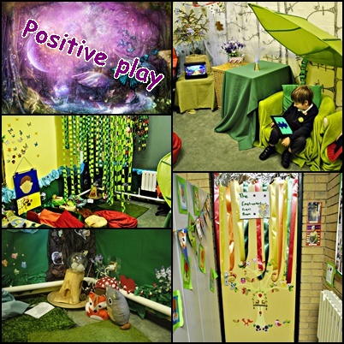 | £10,500 | To allow young people a space to express and communicate feelings and difficulties in their lives, through a variety of media in constructive rather than aggressive ways and in a safe non-threatening environment.  To help young people feel good about themselves, and raise self-esteem by providing activities that look at their strengths and by valuing what they do and making it special.  To provide a non-authoritarian, supportive, reliable, safe, unconditional relationship within the school and other settings.  To help young people acquire the complex range of life skills needed to achieve their full potential.
Lego Therapy    Our own highly skilled nurture practitioner delivers this excellent social development therapy.  During COVID-19 this will be delivered in bubbles. | £2000 | Pupils will improve in their confidence, motivation and attitudes to learning.
PE intervention  Our sports coach delivers small group bespoke sports intervention. | £2500 | Physical activity is key for good mental health and many of these pupils thrive from being given this opportunity.
Teaching and Learning
Provision | Allocation | Desired Outcome |  | Actual Outcome
Additional TA support in class across all year groups from reception to year 4   | £30,000 | Teams of teacher’s and TA’s will work effectively together breaking away from a model of deployment where TA’s are assigned to specific pupils for long periods. It is important that TA’s add value to the work of the teacher, not replace them- the expectation should be that the needs of all pupils are addressed first and foremost through high quality classroom teaching. Fulfen will organise classrooms so that pupils who struggle the most have as much time with the teacher as others.  The majority of pupils will make better than expected progress.  Some pupils are allocated 1:1 support within individual circumstances.
CPD of Teaching staff and Teaching assistants | £3500 | Research has proven that improving the quality of TA’s talk to pupils can support the development of independent skills which are associated with improved learning outcomes.  TA’s and teacher will continue to be trained on developing pupils independent and ownership skills. 52% of disadvantaged pupils are also SEND pupils.  Ongoing training on attachment and trauma is fundamental to understand the needs of pupils from disadvantaged backgrounds.  Invest in a whole school approach into a ‘Relationship Policy’. Develop strategies within all staff at Fulfen to ensure that high self-esteem is promoted at all times. Ensure that staff have the skills to deal with pupils in a empathetic way.
Intervention  Intervention is available to all pupils on a need’s basis in all year groups and will be reviewed every six weeks at pupil progress meetings.  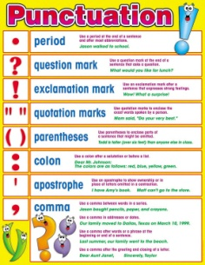 | £22,000 | TA’s will deliver high quality targeted intervention in one to one and small groups settings.  TA’s will continue to receive ongoing CPD and the interventions will be reviewed half termly to ensure that they are having impact.  Sessions will be at least 3 times weekly to ensure they have impact and will be maintained over a period of time.
Resources  Every pupil will be equipped with any resources that are needed for school.   | £1500 | Every pupil will be equipped with any resources that are needed for school. For example, water bottles, uniform, stationary etc.  Individual pupils may need a selection of resources to help them feel calm and happy in school or to enable them to concentrate. This is all purchased on a need’s basis.  Equality of education and opportunity for PP pupils, alongside non-PP pupils.
Snacks at Break time  FSM children will be able to have a snack and a drink at break time. | £500 | Snacks at break time will be available to all pupils who are pupil premium.  Equality of education and opportunity for PP pupils, alongside non-PP pupils.
Enrichment
Provision | Allocation | Desired Outcome | Actual Outcome
Academic Trips and Events  The PP Grant will pay for day trips and residential trip.   | £3000 | All pupils will be able to attend educational trips paid for through pupil premium. This is absolutely necessary to ensure that they receive these experiences and the curriculum can be brought to life.  Equality of education and opportunity for PP pupils, alongside non-PP pupils.
Sport Provision  - Daily lunchtime clubs  - Daily after school clubs   | £7000 | Fulfen employs two qualified sports coaches to deliver high quality sporting experiences for the pupils. More pupils will have the opportunity to develop a variety of new skills.  Develop and improve gross motor skills.  Equality of education and opportunity for PP pupils, alongside non-PP pupils.
iPad’s  Pupil premium pupils in year 3 are able to access iPads at a discounted rate. | £1000 | Equality of education and opportunity for PP pupils, alongside non-PP pupils.
9

