Action Plan for 2019/20

Provision | Allocation | Desired Outcome | Actual Impact to date due to COVID-19
Positive Play Programme  The Positive Play Programme is to raise the self-esteem of children and young people, helping them to access the curriculum and so achieve their potential  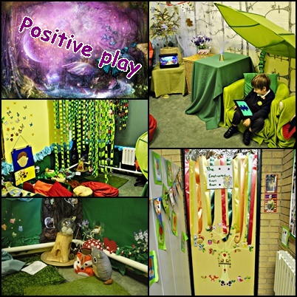 | £10,000 | To allow young people a space to express and communicate feelings and difficulties in their lives, through a variety of media in constructive rather than aggressive ways and in a safe non-threatening environment.  To help young people feel good about themselves, and raise self-esteem by providing activities that look at their strengths and by valuing what they do and making it special.  To provide a non-authoritarian, supportive, reliable, safe, unconditional relationship within the school and other settings.  To help young people acquire the complex range of life skills needed to achieve their full potential. | The positive play programme has had a significant impact on pupil’s social emotional and mental health needs. Case studies and Boxall profiles demonstrate the progress and impact the programme has had on individual pupils.  From March until July all pupils on the programme received weekly phone calls. They carried out various activities over the phone and parents and carers were also supported during this difficult period.  Feedback was very positive and the pupils looked forward to the phone calls.  All pupils also received an activity pack to promote self esteem at home.  Phone calls were arranged around the school day if the pupils were still accessing full time school during lockdown.  There was also a dedicated positive play email address for parents to contact the positive play worker at any point during lockdown about the wellbeing of the children and if the parents required support.
Teaching Assistants  Use TAs to deliver high quality one to one and small group support using structured interventions   | £20,000 | The gap between pupil premium pupils and their peers will close significantly.  The majority of pupils will make better than expected progress. | Specific targets set for individual pupils teaching targeted to meet needs.  Close liaison between teachers and teaching assistants- shared understanding of the pupils needs.  Consolidation of learning and pre-teaching has prepared pupils and they are becoming more confident in tackling work independently.  Regular reading session has increased the skills and confidence of pupils.  Teachers and TA’s are aware of specific targets for pupils and support in classes are tailored towards this.  Pupils have access to personalised resources.  Focused pupil progress discussions review impact of intervention through provision mapping.  During lockdown teaching assistants sent personal video messages and activities such as telling children stories.  During lockdown teaching assistants planned and set personal intervention for pupil premium pupils via the seesaw app. Children were given feedback and specific targets.
Lego Therapy    Our own highly skilled nurture practitioner delivers this excellent social development therapy. | £2000 | Pupils will improve in their confidence, motivation and attitudes to learning. | A series of observations prior to lockdown revealed that Lego therapy improved the social interaction between pupils both verbal and non-verbal. It also improved motivation and attitudes to learning.  This was then replaced by individual phone calls and activities for pupils who were learning from home.  Vulnerable children accessing school in lockdown continued to access a variety of nurture therapies in their bubbles.
Intervention  Intervention is available to all pupils on a needs basis in all year groups and will be reviewed every six weeks at pupil progress meetings.  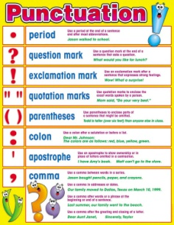 | £8820 | The gap between pupil premium pupils and their peers will close significantly. | Specific targets set for individual pupils teaching targeted to meet needs.  Close liaison between teachers and teaching assistants- shared understanding of the pupils needs.  Consolidation of learning and pre-teaching has prepared pupils and they are becoming more confident in tackling work independently.  Regular reading session has increased the skills and confidence of pupils.  Teachers and TA’s are aware of specific targets for pupils and support in classes are tailored towards this.  Pupils have access to personalised resources.  Focused pupil progress discussions review impact of intervention through provision mapping
Resources  Every pupil will be equipped with any resources that are needed for school.   | £1500 | Every pupil will be equipped with any resources that are needed for school. For example, water bottles, uniform, stationary etc.  Equality of education and opportunity for PP pupils, alongside non-PP pupils. | All pupils are equipped with resources as appropriate and on a needs basis.  At the beginning of lockdown before the FSM vouchers were introduced by the government every PP family were delivered a package of essential food and household essential items. The package had essential items to last at least four weeks.
Snacks at Break time  FSM children will be able to have a snack and a drink at break time. | £500 | Snacks at break time will be available to all pupils who are pupil premium.  Equality of education and opportunity for PP pupils, alongside non-PP pupils. | Pupils receive fresh snack every breaktime.
Academic Trips and Events  The PP Grant will pay for day trips and residential trip.  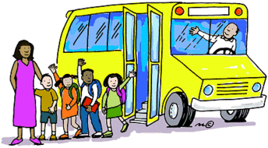 | £5000 | All pupils will be able to attend educational trips paid for through pupil premium.  Equality of education and opportunity for PP pupils, alongside non-PP pupils. | Fulfen ensures that all PP children receive the same experiences as non PP pupils.
Sport Provision  - Daily lunchtime clubs  - Daily after school clubs  - PE Intervention x2 weekly   | £7000 | More pupils will have the opportunity to develop a variety of new skills.  Develop and improve gross motor skills  Equality of education and opportunity for PP pupils, alongside non-PP pupils. | The two sports coaches delivered high quality lunchtime sports provision and daily after school clubs to ensure that pupil premium experience a range of activities.  The sports coaches also delivered high quality PE intervention for gross and fine skills as well as addressing social, emotional and mental health needs.  Throughout lockdown the sports coaches delivered intervention to small groups accessing full time school throughout lockdown.
iPad’s  Pupil premium pupils in year 3 are able to access iPads at a discounted rate. | £500  £1500 | Equality of education and opportunity for PP pupils, alongside non-PP pupils. | All pupils in year 3 have received the iPad at a discounted rate.  During lockdown all PP were loaned an electronic device from school to access the remote learning.
 |  | Total Expenditure: | £56,820
9

