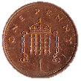
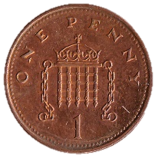
Penny War!!

24th February – 3rd April
Put your spare change towards a good cause. All proceeds go towards wet play equipment for our children.

Pennies are positive. Here’s how it works:
- Containers will be located in the hall.
- Each penny collected counts as one positive point towards YOUR year group.
- Each two pence counts as two positive points for YOUR year group.
- Each silver coin counts as negative points for OTHER year groups. In other words, dropping a 5p in another year group’s container counts as 5 points against their total!
- At the end of each week, coins will be counted and the winning year group will receive a small prize – for example extra break time or sweets!
- At the end of the competition, the overall winning year group will enjoy a movie afternoon with drinks and snacks.
- Any extra money raised will go towards toys and games to be used during wet play across the school.

Start saving your change – it can make a big difference!

Thank you for your support,
Mr Gleeson, Miss Morgan
and the school council.
Harry, Gracie, Izzy, Ethan, Ella,
Katie, Samuel & Jessica

