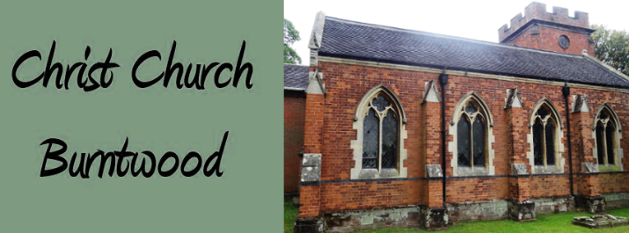
Community Christmas at Burntwood Church

From Dec 1st



Please help Burntwood Christ Church look fesitive this year.

Our community are being asked to hang Christmas decorations in the Church grounds. They can be home made or shop bought, the more festive the better.

Just take you decorations at any time and pick a tree to display your bells, angels, stars, baubles or even candy canes from.
Thank you

