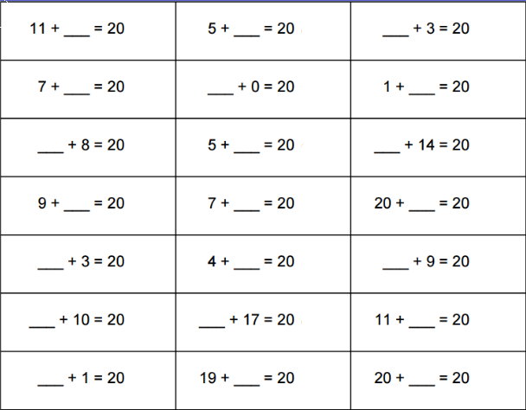
Name:
Speed Challenge!
Number pairs to 20.
How fast can you answer these questions?
Get someone to time you!

