

Smallwood CE Primary Academy

Collective Worship Timetable
Summer Term 2025
The Church Year starts at Advent. In church different colours represent different seasons. The worship area in the hall, has different colour cloths to represent the time in the Church Year. This can be referred to in your collective worship time.
Purple: Penance and Preparation   | Red: Sacrifice, the Holy Spirit   | Green: Hope, Life and Growth   | Gold: Joy and Celebration   | White: Purity   | No colour: Desolation  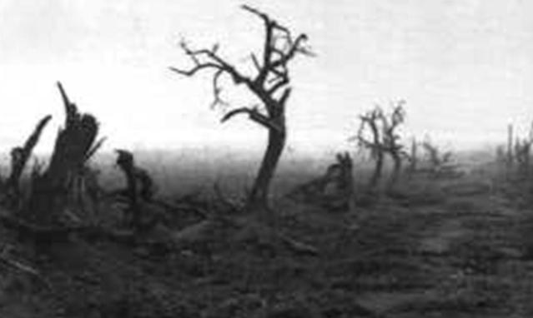
Purple is used for times of deep thinking and reflection. It is also sometimes used at adult funerals. | Red is used for saints’ days who have died as martyrs and also represents the flame of the Holy Spirit. | Green is used to represent quiet growth during the time between festivals and seasons. | Gold used for special occasions. | White represents purity (as opposed to sin which is scarlet). It often represents a season of celebration rather than a day. | On these two days of the year the church is stripped bare of all decoration and flowers.
Used during Advent and Lent | Pentecost/Whitsun  Martyr’s saints’ days | Used throughout Ordinary Time. | Used for special days of celebration, such as Easter Day and Christmas | Used in the seasons of Easter and Christmas and for saints who were not martyred. | Good Friday and Holy Saturday
.

 |  |  | Useful links for worships
 |  | Theme
Date | Led by | Theme
 |  | Bank Holiday
22.4.25 | IL
22.4.25 | IL | Term 1 theme: THANKFULNESS  'Always be thankful' 1 Thessalonians 5.16 | ‘Roots and Fruits’ Collective Worship Book
23.4.25 | KC | St George’s Day | SPCK Assemblies - St George’s Day
24.4.25 | JD | Hymn Worship
25.4.25 | IL | Celebration Worship
28.4.25 | IL | Christian Values 2: TRUST  'My God is my strength in whom I trust' Psalm 18.2 | ‘Roots and Fruits’ Collective Worship Book
29.4.25 | Class teachers | Class Based Worship (Including reflection on Monday’s theme)
30.4.25 | WP | Christian Values 3: PERSEVERANCE  'I can do all things through Him who strengthens me' 1 Philippians 4.13 | ‘Roots and Fruits’ Collective Worship Book
1.5.25 | JD | Hymn Worship
2.5.25 | JP | Celebration Worship
 |  | Bank Holiday
6.5.25 | JP/JD | Key Stage Worship (Reflect on the Christian Values covered in worship so far this term: Thankfulness; Trust; Perseverance)
7.5.25 |  | Beech Class Worship: Christian Values
7.5.25 | Beech Class | Beech Class Worship: Christian Values
8.5.25 | JD
8.5.25 | JD | Hymn Worship
9.5.25 | KC | Celebration Worship
12.5.25 | IL | Christian Values 4: JUSTICE  'Learn to do right. Seek justice' Isaiah 1.17 | ‘Roots and Fruits’ Collective Worship Book
13.5.25 | Class teachers | Class Based Worship (Including reflection on Monday’s theme)
14.5.25 |  | May 12 – Buddhist: Vesak (Buddha Day)  Celebrates the birth, enlightenment, and death of Buddha. | SPCK Assemblies - The Buddha's Birth, Enlightenment and Death
14.5.25 | JP
15.5.25 | JD | Hymn Worship
16.5.25 | IL | Celebration Worship
19.5.25 | IL | Christian Values 5: SERVICE  'Serve one another in love' Galatians 5.13 | ‘Roots and Fruits’ Collective Worship Book
20.5.25 | KC/WP | Key Stage Worship (Including reflection on Monday’s theme)
21.5.25 |  | Maple Class Worship: Christian Values
21.5.25 | Maple Class | Maple Class Worship: Christian Values
22.5.25 | JD | Hymn Worship
23.5.25 | IL | Celebration Worship
 |  | HALF TERM
2.6.25 | IL | June 2-3 – Jewish: Shavuot*  Celebrates the giving of the Torah at Mount Sinai. | Resources available on Twinkl and on BBC Teach
3.6.25 | Class teachers | Class Based Worship (Including reflection on Monday’s theme)
4.6.25 | AH | Christian Values 6: TRUTH  'Tell the truth to each other' 1 Zechariah 8.16 | ‘Roots and Fruits’ Collective Worship Book
5.6.25 | JD | Hymn Worship
6.6.25 | KC | Celebration Worship
9.6.25 | IL | Christian Values 7: COMPASSION  'Clothe yourselves with compassion, kindness, humility, gentleness and patience' Colossians 3.12 | ‘Roots and Fruits’ Collective Worship Book
10.6.25 | DL/BM | Key Stage Worship (Including reflection on Monday’s theme)
11.6.25 | Oak Class | Oak Class Worship: Christian Values
12.6.25 | JD
12.6.25 | JD | Hymn Worship
13.6.25 | IL | Celebration Worship
16.6.25 | IL | Christian Values 8: COURAGE  'Be strong and courageous; do not be frightened or dismayed, for the Lord your God is  with you wherever you go.' Joshua 1.9  Courage is not the absence of fear. It is acting in spite of it. Mark Twain | ‘Roots and Fruits’ Collective Worship Book
17.6.25 | Class teachers | Class Based Worship (Including reflection on Monday’s theme)
18.6.25 | NP | Christian Values 9: FORGIVENESS  'Just as the Lord has forgiven you, so you must also forgive others' Colossians 3.13  It takes a strong person to say sorry, and an even stronger person to forgive. Anon | ‘Roots and Fruits’ Collective Worship Book
19.6.25 | JD | Hymn Worship
20.6.25 | JP | Celebration Worship
23.6.25 | IL | Christian Values 10: FRIENDSHIP  'Encourage one another and build each other up' 1 Thessalonians 5.11  Friends are like the walls of a house. Sometimes they hold you up, sometimes you lean on them, but sometimes it's enough to know they're just standing by. Anon. | ‘Roots and Fruits’ Collective Worship Book
24.6.25 | AH/JD | Key Stage Worship (Including reflection on Monday’s theme)
25.6.25 | Hazel Class | Hazel Class Worship: Christian Values
26.6.25 | JD | Hymn Worship
27.6.25 | KC | Celebration Worship
30.6.25 | IL | Christian Values 11: RESPECT  'Do to others as you would have them do to you' Matthew 7.12 | ‘Roots and Fruits’ Collective Worship Book
1.7.25 | KC/NP | Class Based Worship (Including reflection on Monday’s theme)
2.7.25 | Elm Class | Elm Class Worship: Christian Values
3.7.25 | JD | Hymn Worship
4.7.25 | JP | Celebration Worship
7.7.25 | IL | TBC
8.7.25 | Class teachers | Key Stage Worship (Including reflection on Monday’s theme)
9.7.25 | Ash Class | Ash Class Worship:
10.7.25 | JD | Hymn Worship
11.7.25 | KC | Celebration Worship
14.7.25 | IL | TBC
15.7.25 | Class teachers | Class Based Worship (Including reflection on Monday’s theme)
16.7.25 | Willow Class | Willow Class Worship: Christian Value of Friendship and favourite Memories from Reception Class
17.7.25 | JD | Hymn Worship
18.7.25 |  | Leavers’ Service in church at 9 a.m.
 |  | SUMMER HOLIDAYS

