Handwriting policy

Smallwood CE Primary Academy



Approved by: | Iestyn Lewis | Date: September 2024
Last reviewed on: | September 2024
Next review due by: | September 2025

Contents

1. Policy Statement
- Our handwriting policy is underpinned by research and covers all the requirements of the 2014 National Curriculum. Handwriting is a basic skill that influences the quality of work throughout the curriculum.
- We use our own bespoke scheme which has been informed by ‘Teach Handwriting’ as well as other research and resources within the field.
- At the end of Key Stage 2, all pupils should have developed fluid, legible, joined up handwriting when writing at speed. We aim to make handwriting an automatic process that does not interfere with creative writing and natural flow.

2. Intent

- We aim for our pupils to develop a neat, legible, handwriting style using cursive letters that leads to producing letters and words automatically in independent writing. This means that they can produce and maintain good speed; have a fluid hand movement that is comfortable, and letters are of a consistent and appropriate size, positioned correctly.
- By the end of Year 6, pupils will understand the importance of neat presentation and the need for different letterforms (cursive, printed or capital letters) to help communicate meaning clearly.
- Our aim is to help pupils enjoy learning and developing their handwriting with a sense of achievement and pride.

Implementation

Our teachers use and model handwriting in line with the handwriting style taught in that year group for all handwriting tasks. We first teach the print font style, then the single letter continuous cursive font style and finally the letter joins.

Pupils should experience coherence and continuity in the learning and teaching of handwriting across all school years and be encouraged to take pride in the presentation of their work.

Handwriting is a cross-curriculum task and will be taken into consideration during all lessons.

Formal teaching of handwriting is to be carried out regularly and systematically following our bespoke long-term scheme of work to ensure Key Stage targets are met.

The following three stages of handwriting are adhered to across school:

Stage | Content | Detail | Year Groups
1 | Pre-handwriting patterns | Learning pre-handwriting patterns is the important first step in handwriting.  Pre-handwriting patterns help a child to learn the shapes and directional pushes and pulls of the writing tools required to form letters. All letters are a combination of these shapes and lines.  Once the pre-handwriting patterns have been mastered a child will have the skill base necessary, and be more confident, to form letters, numbers, symbols (and later on the join strokes required for a joined fluid and speedy handwriting style.) | EYFS
2 | Single letter and number formation  *Starting with print and moving onto continuous cursive in the Spring term of Y1. | To begin with, learning to write letters or numbers is about learning to move a pencil in the correct directional sequence of movements; size is not important at this stage.  Once the letters can be formed, a child can then focus on the size and position of the letters in relation to each other (Refiners). The size and accuracy of the letter shapes decrease and improves as a child’s gross and fine motor skills (Key Strengths) develop.  Once a child is ready to start a more focused formal approach to learning how to form single letters or numbers, it is important to also introduce the other Key Ability skills required for handwriting:  sitting correctly at a desk - it is important to ensure that their sitting position and table height are correct for them.  pencil grip - that it is appropriate for the child’s developmental stage and age.  paper position - for younger children this may still be on a vertical surface allowing them to make big movements in-line with their pencil grip stage.  It is important to learn how to form letters correctly to begin with as this makes the transition from single letter formation to joined letter handwriting much easier.  Once a child has mastered and is able to form lower-case letters of a consistent size, and have them correctly positioned in relation to one another in print, they are ready to then learn the entry and exit strokes before being ready to join their writing. | EYFS/ KS1
3 | Joining letters | Handwriting styles which allow all the lower-case letters to join are best for children as they make their handwriting fluent and quick, by reducing the strain on their hand, wrist and fingers.  As a child’s fine motor skills develop it enables them to form smaller more refined versions of the letters and it is more appropriate to use handwriting lines at this point.  A child is ready to join letters when:  They have learnt to form all the lower-case letters correctly (in print and in continuous cursive)  Letters are of a consistent and suitable size (for younger children these may be large in size but consistent).  Letters are positioned appropriately on the writing line as well as in relation to one another.  Teaching the different join types in specific groups helps a child to understand the directional pushes and pulls required to successfully join the different letter combinations. | KS2

Posture and grip
- Pupils should be taught to sit correctly at a table, holding a pencil comfortably and correctly.
- Both right- and left-handed children should be encouraged to use the tripod grip which allows the pen/pencil to be held securely whilst allowing controlled movements of the pen/pencil nib.
- The table should reach below elbow height. Children should be encouraged to: Sit with a straight back, not leaning over the page; sit right back in the seat, pull the chair close into the table and keep feet flat on the floor; grip the pencil with their index finger and thumb with the nib pointing away.
- Left-handed children may find it difficult to follow right-handed teachers as they demonstrate letter formation (and vice versa). Teachers should demonstrate to left-handers on an individual or group basis where possible.
- Left-handed pupils should sit to the left of a right-handed child so that they are not competing for space.
- Pupils should position the paper/book to their left side and slanted, as shown.
- Pencils should not be held too close to the point as this can interrupt pupils’ line of vision.
- Extra practice with left-to-right exercises may be necessary before pupils write left-to-right automatically.

Inclusion
- Children whose handwriting is limited by problems with fine motor skills, including left-handed children, and children with special educational needs, will be given additional support to help achieve their optimum handwriting level.
- It might be the case that certain individuals continue to write in print as opposed to in a continuous cursive style regardless of their age/ stage.

Pens and Pencils
- Children are encouraged to start handwriting using a pencil.
- To ensure inclusion for all, children will be given a handwriting pen in the Summer Term of Year 6 should they want to use it. *This will be reviewed once handwriting across the school has improved.

Appendix 1
Key Stage Focus/ End Points

EYFS
- Hold a pencil in an effective manner for writing and be encouraged to correct any errors in grip or stature.
- Begin to form printed letters and understand when they are to be used.
- Understand that letters are written on a base line.
- Begin to form capital letters and numerals.
- Have an understanding of writing their own name.
- Understanding different shaped letter families.

KEY STAGE 1
- Write legibly using upper- and lower-case letters (with entry and exit strokes from the Spring Term of year 1).
- Ensure that letters sit on the base line and are consistent in size with ascenders and descenders that are the correct length and formation.
- Leave the correct space between words.
- Form capital letters and use where appropriate.
- Form numerals that are consistent in size and sit on the base line.
- Improve the speed of writing and begin to write automatically so promoting creativity in independent writing.
KEY STAGE 2 (Improve quality, speed and stamina of handwriting)
- Quality: Ensure letters are consistently sized with equal word spacing and that ascenders and descenders are parallel and do not touch words on the lines above and below.
- Speed: Improve speed of handwriting to allow creative writing to take precedence over the task of handwriting and be able to take ‘quick notes’ at a faster pace.
- Stamina: Have the strength and mobility to be able to write for longer periods of time without fatigue.
- Speedy handwriting for note-taking and dictation where neatness is not as important and shortcuts, such as + instead of ‘and’, can be used.

Appendix 1
Print- Letters

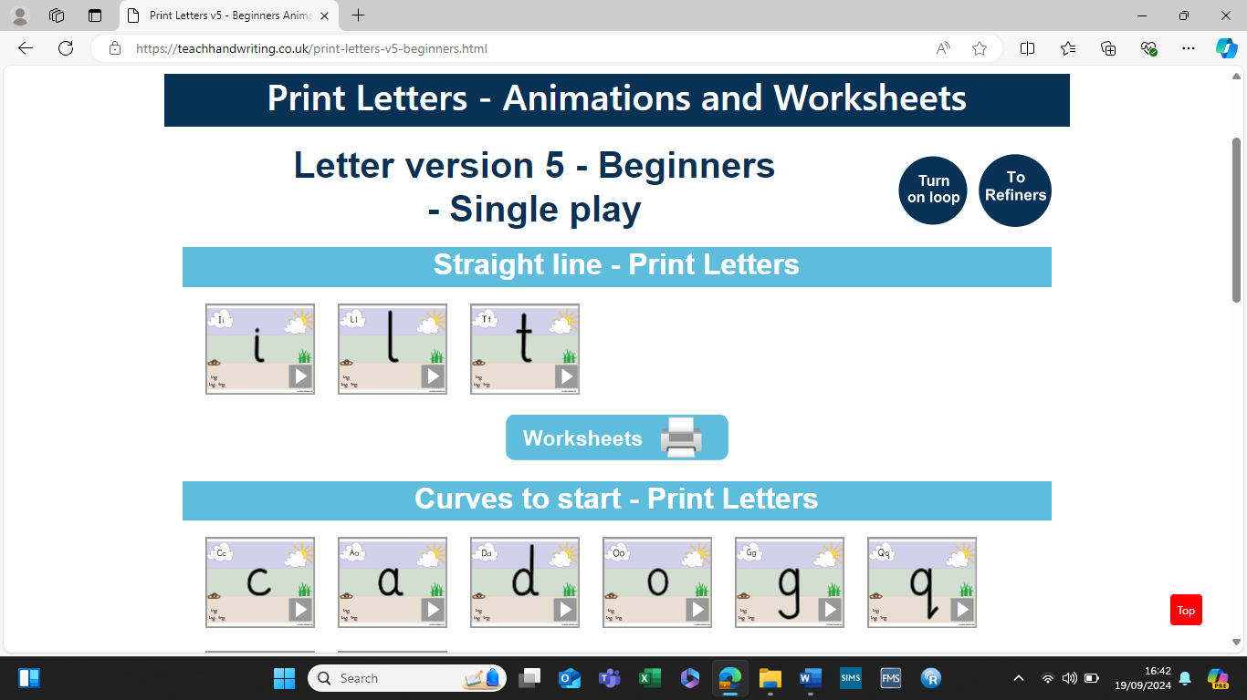
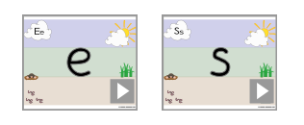

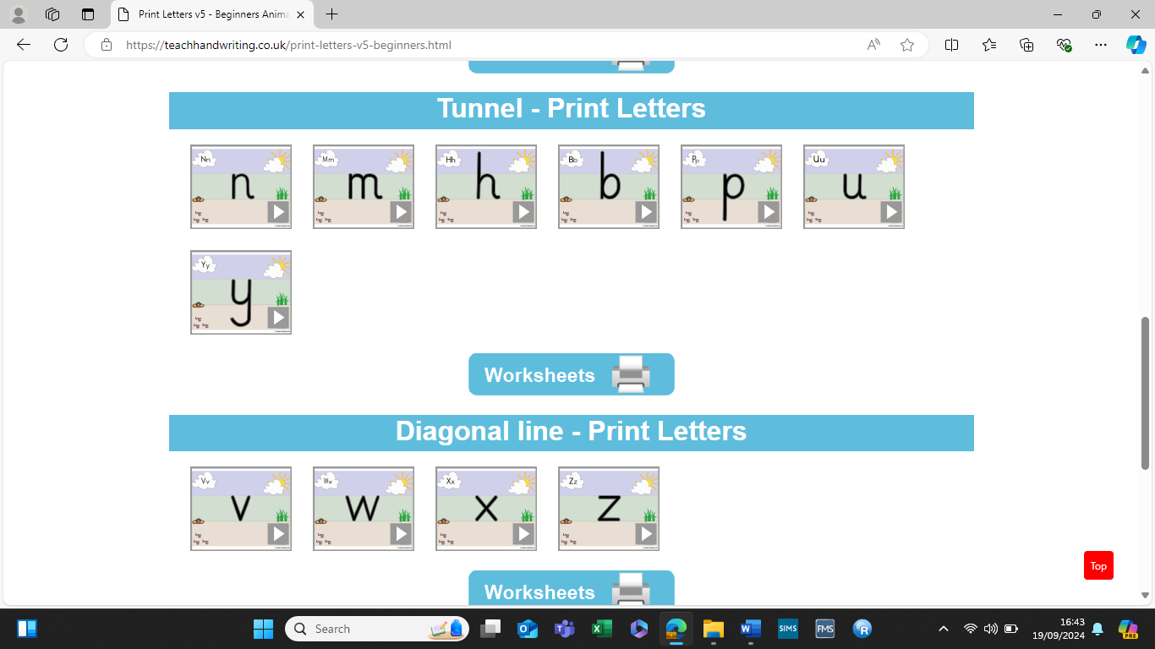

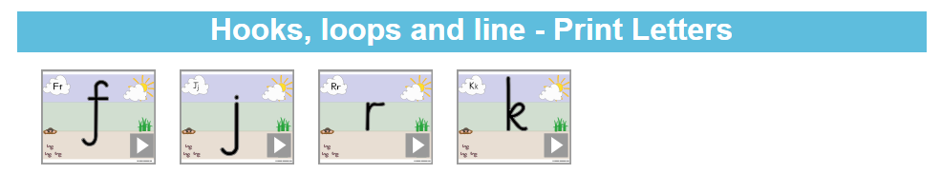

Appendix 2
Continuous Cursive- Letters

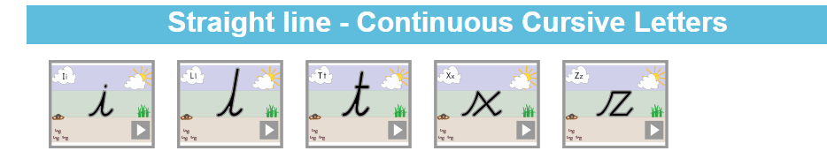

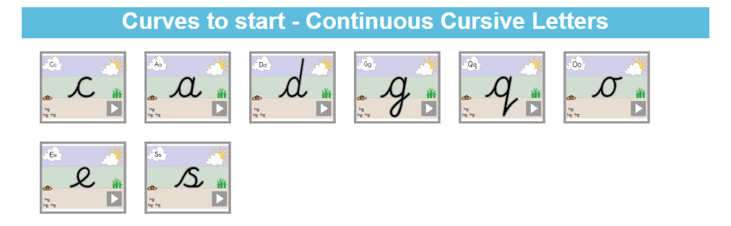

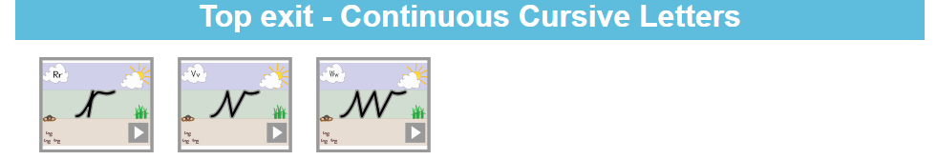

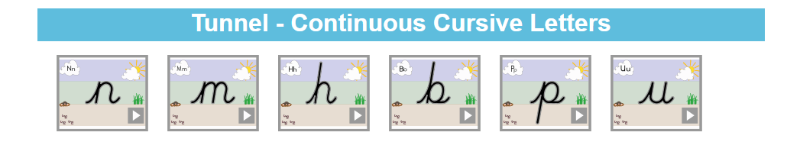

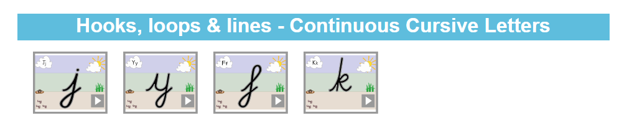

Appendix 2
Continuous Cursive- Letter Joins
