Maple Class, Spring 1
The Romans
All tasks are in addition to times tables practice, daily reading and the learning of weekly spellings. Each activity is optional and worth 2 dojo points. Please provide physical or photographic evidence via class dojo/ email.
Topic | Health/ Wellbeing
Make your own Roman road, you can create this in a shoe box using pebbles, sand etc. or use different foods like smarties, biscuits etc. and photograph or send in! Have fun. Make sure you research how they were made. 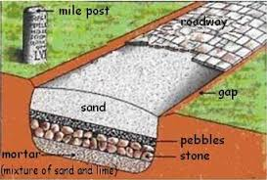 | Visit a museum.  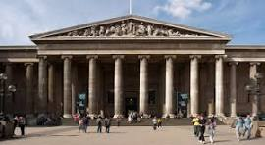
Create your own Roman mosaic.  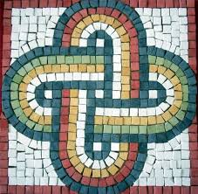 | Light a candle.  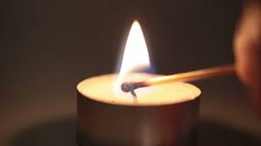
Pick a Roman Emperor, create an information poster about them.  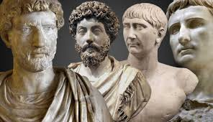 | Write a poem.  
Visit the library or your shelves at home. Read some books about the Romans; create review.  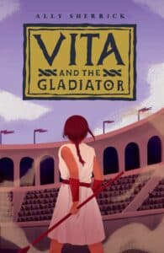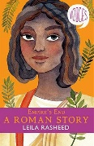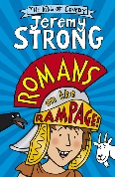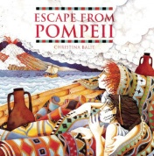 | Climb over rocks.  