Beech Class, Autumn 1
Save Our Planet!

All tasks are in addition to times tables practice, daily reading and the learning of weekly spellings. Each activity is optional and worth 2 dojo points. Please provide physical or photographic evidence via class dojo/ email.

Topic | Health/ Wellbeing
Research Poster  Research what is happening to our oceans and create a poster to display your findings.   | Healthy Food  Research and create a healthy snack! Please seek help from an adult when making your snack.  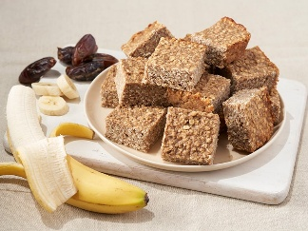
Timeline  Find out about either David Attenborough, Greta Thunberg or Jane Goodall.  Create a timeline of their life and their achievements.   | Thankfulness Log  Keep a thankful log for a week. Each day, reflect on 3 different things you are thankful for and write these down.  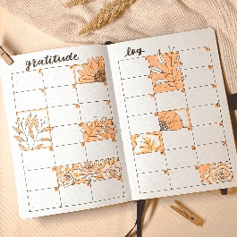
Art  Create a piece of art work inspired by our beautiful planet.  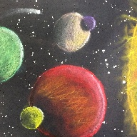 | Exercise - daily mile!  Can you walk a mile every day for 7 days?  
Book Review  Read a book linked to our topic and prepare a small speech to the class about what the book is about and if you would recommend it to others.  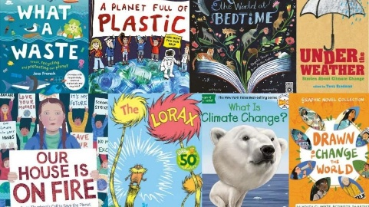 | Something you love  Spend at least 15 minutes a day doing something you love – this could be reading, drawing or going out for a walk.  

