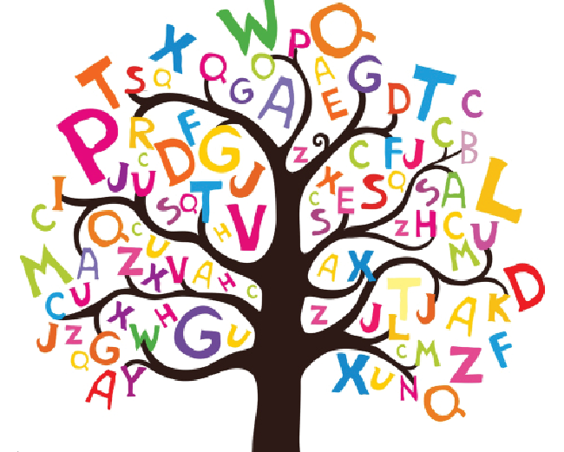
Beech Class Spellings – Autumn 1 - 2025
Below are the spellings for this half term with spelling tests on Fridays. I have added the date of each test at the bottom of each column and key words are highlighted in green. Children will record their weekly scores in their reading records. If you have any questions, please ask – thank you!
Week 1 | Week 2 | Week 3 | Week 4 | Week 5 | Week 6
Words with endings that sound like /shuhs/ spelt with -cious | Words with endings that sound like /shuhs/ spelt with -tious or -ious | Words with the short vowel sound /i/ spelt with a y | Words with a long vowel sound /i/ spelt with a y | Homophones and near Homophones | Homophones and near homophones
vicious  gracious  spacious  malicious  precious  conscious  delicious  suspicious  atrocious  ferocious | ambitious  cautious  fictitious  infectious  nutritious  contentious  superstitious  pretentious  anxious  obnoxious | symbol  mystery  lyrics  oxygen  symptom  physical  system  typical  crystal  rhythm | apply  supply  identify  occupy  multiply  rhyme  cycle  python  hygiene  hyphen | past  passed  proceed  precede  aisle  isle  aloud  allowed  affect  effect | farther  father  guessed  guest  heard  herd  led  lead  mourning  morning
Test on 12th September | Test on 19th September | Test on 26nd September | Test on 3rd October | Test on 10th October | Test on 17th October

