 | Session 1:  9.30 – 10.30 | Session 2:  11.00 – 11.30 | Session 3:  1.00 – 2.00 | Session 4:  2.00 – 3.00
Monday 8th | Let’s get Physical  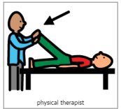  Practicing physical skills as appropriate for your child. | Music and songs with Vicky  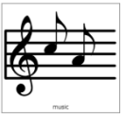  Live on Teams | 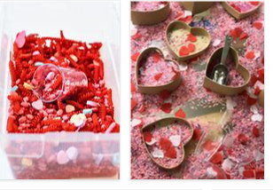  Sensory Mark Making  Explore ways to make marks using your hands. Get messy! This week, we are thinking about Valentine’s Day, getting ready for the Theme Day on Thursday. Can you explore the colour red and/or pink at home? If you have any red food colouring, you could dye some spaghetti or rice red, to explore. If you have any red or pink paint, explore it with your hands and/or feet and make prints. | IEP time  Use this time every day to work on your child’s targets from their IEP. Contact school if you would like to be re-sent the IEP targets sheet.
Tuesday 9th | Let’s get Physical  Practicing physical skills as appropriate for your child. | Music and songs with Vicky  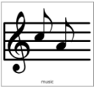  Live on Teams | Story time  Explore reading and sharing books with your child. What are their favourites? Can they help to turn the pages? This week, for Valentines Day, you could share the book ‘Guess How Much I love you’ (you can find an animated version of this on YouTube: www.youtube.com/watch?v-LPLwMxogTDU). Talk about the people that you love and share photos of them with your child.
Wednesday 10th | Circle Time  Live teams with Rebecca  9.30 – 10.00 | Pre-recorded video | Topic – Valentine’s Day  Valentine’s Day activity ideas attached to the email such as:  - Heart-shaped Wreath  - Valentine’s Day Candle Holder  - How to make heart-shaped iced biscuits
Thursday 11th | Circle Time  Live teams with Rebecca  9.30 – 10.00 | Pre-recorded video | 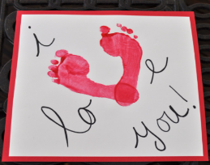  Valentine’s Day – Whole school theme day  Wear red or pink today for our theme day! Can you make a Valentine’s Day card for someone special today? Can you decorate a heart and think of somethings that you/your child loves or are thankful for?
Friday 12th | Let’s get Physical  Practicing physical skills as appropriate for your child. | Music and songs with Vicky  Live on Teams | Calm and Relax (Well-being time)  Spend some quiet time with your child. Make the room dark and play some relaxing music. If you have any sensory lights then you can use these to make a nice quiet atmosphere.  Practice your child’s visual skills of looking, tracking and fixing their gaze on to a bright object. Encourage their communication – how do they show what they liked best, can they ask for more or let you know they have finished?

