 | Session 1:  9.30 – 10.30 | Session 2:  11.00 – 11.30 | Session 3:  1.00 – 2.00 | Session 4:  2.00 – 3.00
Monday 1st | Let’s get Physical  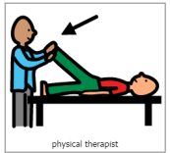  Practicing physical skills as appropriate for your child. | Music and songs with Vicky  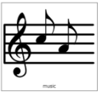  Live on Teams | Sensory Mark Making  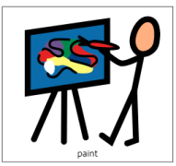  Explore ways to make marks using your hands. Get messy! This week, you will need paints and a sponge. Explore dipping the sponges (you can use ones from your kitchen or bathroom cupboard) into the paints and pressing them to make marks. How does it feel for your child when they squeeze the sponge? Can they drop the sponge to make a ‘splat’? | IEP time  Use this time every day to work on your child’s targets from their IEP. Contact school if you would like to be re-sent the IEP targets sheet.
Tuesday 2nd | Let’s get Physical  Practicing physical skills as appropriate for your child. | Music and songs with Vicky  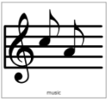  Live on Teams | Story time  Explore reading and sharing books with your child. What are their favourites? Can they help to turn the pages? This week, you could share the book ‘Car Car Truck Jeep’ (video on YouTube). Tap along to the rhythm of the song, alongside the story, to the rhythm of ‘Baa Baa Black Sheep’. You could pause the video to spot and name the different transport that you can see.
Wednesday 3rd | Circle Time  Live teams with Rebecca  9.30 – 10.00 | Pre-recorded video | Body Awareness  Practice your independence skills and keeping clean.  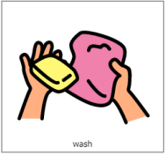  This week, explore washing your face. Look at their face, mouth and teeth in a mirror. Put a smudge of paint/flour on your child’s cheek/chin, look again in the mirror together to point it out. Wash it off with a warm flannel, explore the soapy water and feeling of the soft flannel on your child’s face.
Thursday 4th | Circle Time  Live teams with Rebecca  9.30 – 10.00 | Pre-recorded video | Technology – Making things happen  If you have access to a tablet or iPad, explore ‘Cause and Effect’ apps. If you don’t have access to a tablet, explore electronic toys with your child, such as toys with buttons, musical toys or anything where your child can make something happen. This week, try some musica apps, such as Garage Band, Keezy Drummer. Sensory Sound Box, Piano Kids/simply piano, Xylophone (free).
Friday 5th | Let’s get Physical  Practicing physical skills as appropriate for your child. | Music and songs with Vicky  Live on Teams | Calm and Relax (Well-being time)  Spend some quiet time with your child. Make the room dark and play some relaxing music. If you have any sensory lights then you can use these to make a nice quiet atmosphere.  Practice your child’s visual skills of looking, tracking and fixing their gaze on to a bright object. Encourage their communication – how do they show what they liked best, can they ask for more or let you know they have finished?

