Weekly Home Learning Activities EYFS

Week Beginning: 1st February 2021 | Learning Overview: Our topic this half term is ‘People who help us.’ Our focus text will be ‘Cops and Robbers’. We will learn all about different occupations and how they help us, focusing on the police.
Key learning Focus and vocabulary for this week: Our focus occupation we are learning about this week is ‘dentist’ and our sign/word of the week is therefore ‘dentist’. If you can, please write this word for your child and keep referring to it across the week (this will help pupils become familiar with the shape and recognition of the word).
Please find an image below to help. Following the link, you will find all of the Makaton signs for this half term.
Makaton Topic - PEOPLE WHO HELP US - Singing Hands - YouTube. Dentist is the first sign.

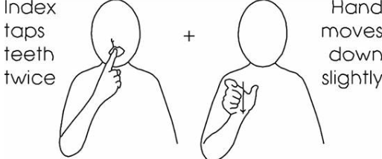

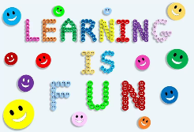

This week I have sent you a reusable dry erase pocket. This will allow you to print off your own activities and use them time and time again! You will also receive a whiteboard marker.

Please upload pictures/videos of your child taking part in these activities onto tapestry or send them to me via email each day. If you have chosen to complete different activities across the day, please share these too/instead. Children learn from anything and everything.

In the Snowy Owls, we recognise that the children learn through repetition and scaffolding support which is why activities are repeated weekly over the half term. Each week we will look at reducing support with the end goal being a truly mastered skill or understanding of a concept.

Key Learning Tasks this week – Target: to complete a minimum of one task each day and upload learning to tapestry/email where you will then receive feedback, support and next steps if required.

Area of learning | Task | Resources
Reading | This half term I would like you to continue to develop a love for books with your child. Ask different members of your household to share favourite books with your child, allowing them to make choices and follow requests.  I have attached the lilac book band level descriptor, to the bottom of this page. Please look at each aspect and work on basic book skills across the week.
Reading | Task 1: Phonics  In the Snowy Owls we are looking a phase 1 activities.  Phase 1 of letters and sounds concentrates on developing children’s speaking and listening skills and lays the foundations for the phonic work which starts in Phase 2. Follow the link to access games within phase 1.  Watch the zoo animals teaching session by following the link. Can your child guess the animal?  Zoo Animal Sounds Listening Game - Phase 1 Phonics - YouTube  You may have animal figures/teddies at home. Make the noise yourself and give your child an option of which animal to choose. For example – make the noise an elephant makes and give your child the option out of an elephant or a cat.  If your child enjoyed this activity, look down the right-hand side – there are many more videos.  If you didn’t get round to completing last week’s activity, try it this week.  PhonicsPlay - Phase 1 Resources  Clicking on teaching ideas icon will explain the game. Clicking on the image will take you to the game.  Start with welcome to the zoo. ‘Meet’ the animals, once you have done this, you can move on guessing the animals. If you have animal figures/teddies at home, you can use these items to demonstrate and consolidate learning.  After playing this game look at sound starters – this is a little trickier.  Extension  - If your child has completed these games with ease, look at the games under phase 2 resources. | - A devise to follow the link
Reading | Task 2: Order  Complete this activity after completing the physical activity below.  Now you know how to brush your teeth, can you place use the Velcro symbols to place this activity in order? As you can see, there are four steps - what do you need to do first?  Discuss the dentist clip with your child and talk them through each step. Why is it important to clean your teeth? You may want to go back to the bathroom to demonstrate the activity.  Extension  - Use the whiteboard pen to draw marks on the laminated mouth. Using an old toothbrush, ask your child to clean the teeth. This activity will help your child to move their fingers and wrist in the correct direction. | - Velcro order sheet  - Laminated mouth  - Tooth brush  - Water
Reading | Task 3: See and learn  See and learn is a program to develop language and early Literacy skills, introducing the vocabulary in the order of the first words most children learn and understand.  Following on from last week’s task, you will receive two new sets of pictures.  Looking at pictures  - Choose a picture  - Attract your child’s attention: Say: “Let’s look at pictures” and give your child time to look at the picture.  - Say the word: Point to the picture and say just the word. E.g. “ball” rather than saying “this is a ball.” Encourage children to point at the picture and pick it up for a closer look if they choose.  - Repeat the word three times: Pause briefly between each repetition so they can take in the information.  - Show your child the next card: Continue same process as first card. Make it into a game e.g. have a bag children can post pictures into after completing them.  It is important that we use very simple language during the activities to make it easier for children to learn the target words.  If you can, it would be beneficial to repeat this task at least 5 times, on different occasions. | - Power point  - Two sets of see and learn pictures
Reading | Task 4: See and learn  Matching pictures  - Place the four new pictures on a table/work top.  - Attract child’s attention: Say “Let’s match pictures.” Encourage them to look at the picture cards.  - Choose a card and pass it to your child.  - Ask your child to match the picture: Point to the picture card that you are asking the child to match and say word e.g. apple. Say “put apple with apple.” At first you may need to prompt your child while they learn the activity. Point to the picture card they need to match their card with and help the child place the card over the matching one if needed. If the child correctly matches say “yes, apple, this is apple”. If modelling or prompting, repeat word after you have matched and say “this is apple – apple.” | - Resources from task 3
Maths | Mathematics is important part of learning for all children in the early years and receiving a good grounding in maths is an essential life skill. As well as numeracy, it helps skills such as problem solving, understanding and using shapes and measure and developing their own spatial awareness.
Maths | Task 1: Number recognition  This week we are focusing on number 4.  Watch and listen to the rhyme ’5 little monkeys jumping on the bed’.  Pay special attention to ‘there’d be 4 little monkeys jumping on the bed’. Sing the song throughout the week and encourage your child to join in. This maybe using body movements, body signs, Makaton, verbal language etc.  Use your laminated number grid to work from 5-1.  Encourage your child to look at each number and repeat its name as they remove it from the number grid.  Pause the song and ask your child to count the monkeys each time the number changes.  Extension – Can you count other objects around the house? Ensure your child stops counting when the objects have ran out. | - Number grid  - A devise to watch and listen to the song.
Maths | Task 2: number recognition  Make a number line. You will receive some white A4 laminated paper, along with numbers to 20.  You may choose to do your number line up to 10, 15 or 20.  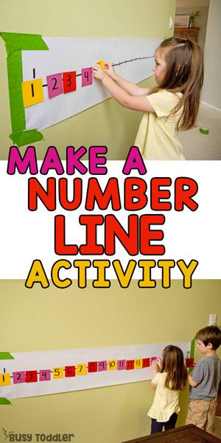  Can you take two numbers off and ask your child what number is missing. Can they recognise the number?  For example – after completing your number line, take number 2 and 4 off. Point to the empty space and ask your child what number is missing. After they have asked correctly, show your child the number 2, and 4 – can they recognise the missing number?  Complete different number rhymes using your number line (1 2 3 4 5, once I caught a fish alive).  Refer back to the number line throughout the week. Below are the number recognition songs we sing at school. Have ago at forming the number alongside the rhyme – you can use the laminated paper and whiteboard pen you received this week.  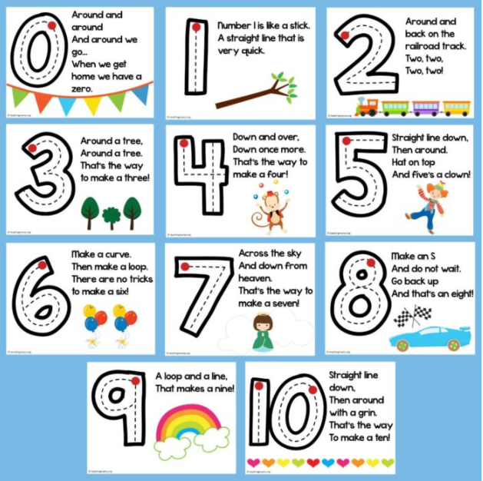  Extension –  Complete the number recognition task from last week, this time using the number 4. | - A4 paper provided  - Numbers to 20  Extension  - A piece of paper with the number 4 written on.  - A piece of paper and a pencil  - 6 household objects/toys to count  - resources to form the number 4  - A wide tub with sand/rice/flour in
Maths | Task 3: Patterns  You will receive pattern sheets. Look at the patterns – what shapes are they? What colours are they?  Can you continue the pattern using the Velcro shapes?  You will receive a second copy unlaminated. Place it in the dry erase pocket – can you draw the next shape?  Extension –  - complete more shape pattern activities at  Shape Patterns (topmarks.co.uk) | - sheets provided  - devise

Useful links, websites and interactive resources
Subject/ Activity | Website and link | What area to focus on
Maths and English | IXL - Reception maths practice | The maths activities will support this week’s activities. You can start at any point between A-G.
Phonics | Phonics play - PhonicsPlay - Phase 1 Resources click on teaching ideas and it will tell you how to play each game. | Any reading game is suitable for the children to use, make sure you click on ‘phase 1’. You can also choose games from ‘phase 2’, if relevant to your child.
Maths | Topmarks Maths -https://www.topmarks.co.uk/Search.aspx?Subject=37 | Games that allow children to practice their counting and sorting maths skills. E.g. Teddy numbers.
Communication and Language, Personal Social and Emotional development, Expressive Arts and Design, Understanding the World, Literacy, Maths. | The Oaks National Academy -  https://www.thenational.academy/online-classroom/specialist/#subjects | You will need to click on the ‘building understanding’ section for each session.
Maths, Phonics, Literacy, Expressive Arts and Design, Understanding of the World | Starfall - http://more.starfall.com/?t=288954945&nrb=1&y=1 | Allow the children to explore and navigate around this website to play on the activities. Make sure you click on ‘Kindergarten’ option.
Sensory App House | https://www.sensoryapphouse.com/ | This website lists a range of sensory apps that are available using android, iOS, and a number can be used web-based. They are separated into “Types” including Cause and Effect, Digital Art, Photo Fun and Entertainment, Relaxation, Sensory Stimulation and Speech Therapy.
Rhyming multisensory stories | https://www.rhymingmultisensorystories.com/ | This website shares a library of multisensory rhyming stories including The Three Little Pigs and A train ride through India. As well as the stories there are areas of the website explaining how to tell a multisensory story and how it can link to the EYFS curriculum.

Other activities for this week (Wider Curriculum/ IEP linked)
Subject | Task | Resources
Expressive art and design  Physical development  Writing | Create a tooth fairy carrier.  You may have different resources to use at home for this activity – small box etc.  I have included an envelope in this weeks posted envelope.  Decorate the envelope, encouraging your child to use their imagination. Can they draw teeth? Can they write to and from on the envelope?  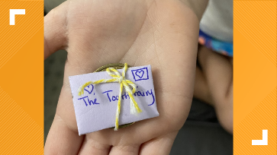  Focus on children holding their pencil correctly, drawing recognisable shapes - circle, lines etc and giving meaning to the marks they make. Ask them what they have draw. | - Coloured paint/pencils or crayons  - Paper
Understanding the world | This week we are looking at how a dentist helps us.  Watch the Something Special clip and discuss what a dentist is and how we brush our teeth.  BBC iPlayer - Something Special - Were All Friends: Series 11: 13. Dentist  Pause at different parts to explain and talk about the dentist’s job.  The dentist will tell you how important it is to brush your teeth.  Try making your own toothpaste and practice brushing your teeth with your child.  Making Toothpaste (taken from Colgate website)  Materials  *4 tsp. baking soda  *1 tsp. salt  *1 tsp flavouring (vanilla, almond or peppermint Extract)  *Toothbrush  *Air-tight containers  Mix well, dampen toothbrush and dip in toothpaste to use. | - Devise  - Ingredients
Physical and wellbeing | Go for a walk around your neighbourhood  Allow your child to choose their own clothes and decide when they would like to go for a walk. Extend their freedom and allow your child to choose the direction of the walk. What can they see on the walk? Is there a particular place your child enjoys walking past?  Talk to your child about their week.  Extension (optional)  - Can your child draw a map that represents their walk?  Or  - Look on google maps (satellite). Follow the paths/roads you went along during your walk. Do you recognise anything familiar – a building, a pond etc.
Extended Learning

- Ask your child to help you prepare a meal for your family. Ask them to wash/cut vegetables (with clear supervision), help get ingredients out of the fridge/cupboard, set the table etc. This will support independence and expose your child to food they would ordinarily refuse to look at.

Please upload pictures/videos of your child taking part in these activities onto tapestry or send them to me via email each day.

 | Phase: 1  (Letters and Sounds) | Level: P4 Name:  (National  Curriculum)
Level Descriptor
Pupils listen and respond to familiar rhymes and stories. They show some understanding of how books work, for example, turning pages and holding the book the right way up
Aspects (Letters and Sounds)
Aspect 1  General Sound Discrimination—environmental | I can listen to sounds  I can listen for brief periods of time  I can repeat specific repetitive lines  I can make the noise in response to a familiar picture or object
Aspect 2  General Sound Discrimination— instrumental | I can move when an instrument is being played  I can indicate the direction of a sound source  I can show my preferences about music or sounds
Aspect 3  General Sound Discrimination— body percussion | I can experience a range of action songs  I can listen to a short story about familiar people, places or events
Aspect 4  Rhythm and Rhyme | I can listen to books with rhymes read with intonation and expression  I can tune into rhythm  I can show pleasure when listening to rhymes, songs etc
Aspect 5  Alliteration | I can explore objects which start with the same initial sound  I can listen as an adult emphasises the initial sound
Aspect 6  Voice Sounds | I can listen as staff talk about pictures  I can, with support, identify familiar voices
Aspect 7  Oral Blending and Segmenting | I can listen to an adult using ‘sound talk’  I can make a choice between two familiar objects, pictures or symbols

Book Skills
I can look at books randomly
I can share a book (mainly pictures) with staff
I can watch staff point to pictures
I can, with support, attempt to find a specific book
I can show interest in books by picking them up and opening them
Key Words and Questions (see Range document for further information)
I can follow requests containing 1 key word
I can make a choice (which?)

Links with EYFS
I can handle books and printed material with interest
I can show that I am developing the ability to follow others’ body language
I can respond to different things said in a familiar context
I can understand single words in context
I can show you that I like to explore a familiar setting
I can use sounds in play e.g. ‘brrrr’ for a car
I can babble and experiment with sounds

