 | Session 1:  9.30 – 10.30 | Session 2:  11.00 – 11.30 | Session 3:  1.00 – 2.00 | Session 4:  2.00 – 3.00
Monday 25th | Let’s get Physical  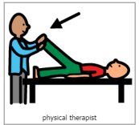  Practicing physical skills as appropriate for your child. | Music and songs with Vicky  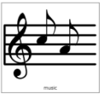  Live on Teams | Sensory Mark Making  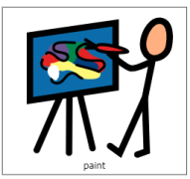  Explore ways to make marks using your hands. Get messy! This week, you will need some shaving foam or gel. If you don’t have any, using shower gel or shampoo from your bathroom cupboard would work well. Explore the shaving foam with your hands to make marks, then add paint or food colouring to make patterns. | IEP time  Use this time every day to work on your child’s targets from their IEP. Contact school if you would like to be re-sent the IEP targets sheet.
Tuesday 26th | Teams Meeting  Live teams chat with Emily  9.30 – 10.00 | Pre-recorded video | Story time  Explore reading and sharing books with your child. What are their favourites? Can they help to turn the pages? This week, we are reading the book ‘Tanka Tanka Skunk’. Watch the telling of the story on YouTube – ‘Symphony Storytime: Tanka Tanka Skunk. Play along to the story by tapping out the rhythm of each of the names. Practice tapping out the different syllables of the animal names on your child’s lap, tray or table.
Wednesday 27th | Let’s get Physical  Practicing physical skills as appropriate for your child. | Music and songs with Vicky  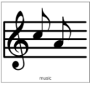  Live on Teams | Body Awareness  Practice your independence skills and keeping clean.  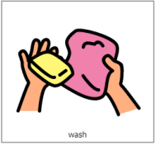  This week, explore teeth brushing. Look at their face, mouth and teeth in a mirror. Explore the feeling of the toothbrush; does your child like the texture on their lips, cheek, hands? Smell the toothpaste, look for how your child reacts. Can your child be supported to hold the toothbrush and try to brush their own teeth, can they try and do it independently or with some help?
Thursday 28th | Teams Meeting  Live teams chat with Emily  9.30 – 10.00 | Pre-recorded video | Technology – Making things happen  If you have access to a tablet or iPad, explore ‘Cause and Effect’ apps. If you don’t have access to a tablet, explore electronic toys with your child, such as toys with buttons, musical toys or anything where your child can make something happen. This week, try Fireworks Arcade app.
Friday 29th | Let’s get Physical  Practicing physical skills as appropriate for your child. | Music and songs with Vicky  Live on Teams | Calm and Relax  Spend some quiet time with your child. Make the room dark and play some relaxing music. If you have any sensory lights then you can use these to make a nice quiet atmosphere.  Practice your child’s visual skills of looking, tracking and fixing their gaze on to a bright object. Encourage their communication – how do they show what they liked best, can they ask for more or let you know they have finished?

