 | Session 1:  9.30 – 10.30 | Session 2:  11.00 – 11.30 | Session 3:  1.00 – 2.00
Monday 18th | Let’s get Physical  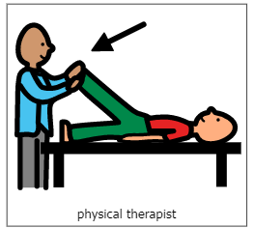  During this time each day, practice physical skills as appropriate for your child. This might be floor time, stretches, or active physical movement. | Music and songs with Vicky  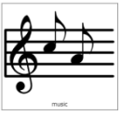  Live on Teams | 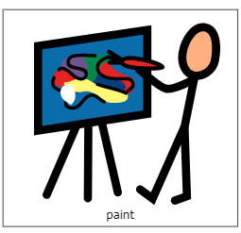  Sensory Mark Making  Explore ways to make marks using your hands. Get messy!  This week, you will need paints and tin foil. Explore making marks on the tin foil using the paints with your hands or a brush.
Tuesday 19th |  | Pre-recorded video | Story time  Explore reading and sharing books with your child. What are their favourites? Can they help to turn the pages?  This week, you could join the Story Massage group on Facebook. They are doing a live Facebook story session at 2pm. Please get in touch if you would like support to access this.
Wednesday 20th |  | Music and songs with Vicky  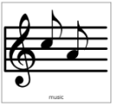  Live on Teams | Body Awareness  Practice your independence skills and keeping clean.  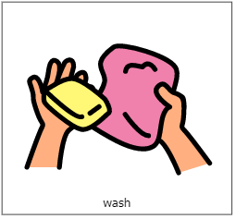  This week, explore hand washing. You will need a bowl of warm water to explore. Try different scented soaps or body washes to wash your child’s hands. Dry their hands and use hand cream for a hand massage.
Thursday 21st |  | Pre-recorded video | Technology – Making things happen  If you have access to a tablet or iPad, explore ‘Cause and Effect’ apps. If you don’t have access to a tablet, explore electronic toys with your child, such as toys with buttons, musical toys or anything where your child can make something happen. This week, try apps from HelpKidzLearn, such as ‘Photo Booth’ or ‘Car wash’. These are free on the app store.
Friday 22nd |  | Music and songs with Vicky  Live on Teams | Calm and Relax  Spend some quiet time with your child. Make the room dark and play some relaxing music. If you have any sensory lights then you can use these to make a nice quiet atmosphere.  Practice your child’s visual skills of looking, tracking and fixing their gaze on to a bright object. Encourage their communication – how do they show what they liked best, can they ask for more or let you know they have finished?

