Every minute matters, Every second counts!
As a parent or carer you can help us personalise your child’s learning by:
- Liaising with school, using the home school diaries, email, meetings and phone calls, letting school know about your child’s range of experiences, new interests or developments in their learning;
- Working on the same learning targets in school and at home;
- Looking at the things your child is learning at school and helping your child to experience it in a different way e.g. if they are learning about numbers at school – then at home, looking at the numbers on doors/cars/price labels/costs etc; and
- Providing activities that will contextualize learning at home and school and will enable learners to develop lifelong skills, e.g. writing the shopping list, (or arranging/choosing the symbols or pictures) going to the shops, finding the items, carrying them home and putting them away and later using them to help cook dinner.

For Foundation Stage/ Primary learners:
- Encourage language and communication through play; talk about what you and your child are doing, “putting the man in the car, taking the man out of the car, finding the blue car,” etc. Extending what they are communicating e.g. “Car” “Blue car” “Big blue car” “Big blue car with a man in.” etc. adding a word/sign/symbol onto the sentence.
- Encourage the use of their imagination in play.
- Provide access to sensory and messy play activities.
- Talk to your child about the environment around them; and helping them to experience it e.g. moving through the long grass, letting them investigate things around them.
- Read to your child as often as you can.
- Encourage the development of self-care skills; brushing teeth, dressing, undressing, swimming, washing hands, using the toilet.
- Get them to think by asking them questions; e.g. ‘What do you think might happen?’ ‘Which way do you think we should go?’ ‘Why do you think that happened?’ ‘What is happening?’ Getting them to work things out, think how things fit together, ‘what goes with what?’
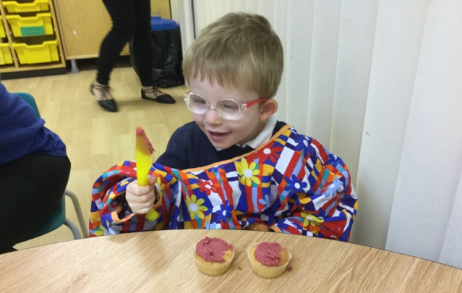

For Secondary/ Post 16 learners:
- Encourage independence and life skills through: shopping, independent travel, telling the time, money management, developing home life skills, cooking.
- Take time to share your child’s interests and allowing them to communicate about them.
- Encourage learners to take responsibility for their belongings.
- Read with your child.
- Get them to think by asking them questions; e.g. What do you think might happen? Which way do you think we should go? Why do you think that happened? What is happening? Getting them to work things out, think how things fit together, what goes with what?
- Support their understanding of situations and characters in films, stories or soap operas to enable them to ‘read’ things which they may misinterpret.
- Support their communication through social networking and helping them to understand difficult situations which could occur.
- Talk to your child about the technologies they use and the benefits and dangers of them. There is a supportive website at: www.thinkyouknow.co.uk
- Talk to your child about being healthy and other dangers such as staying safe in the home and road safety. This website has some good tips and resources: http://think.direct.gov.uk/education/early-years-and-primary/pupils/over-7s/

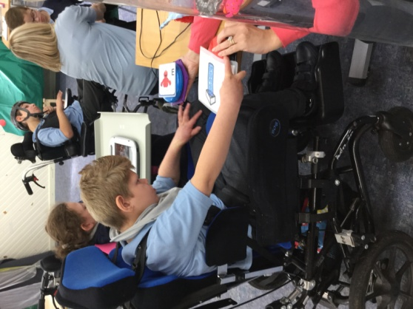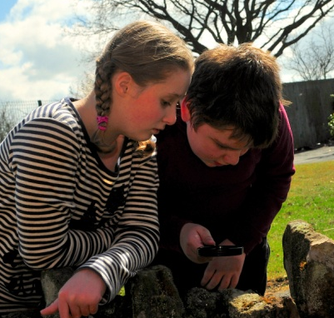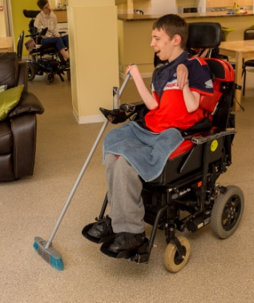

For Pathway One learners:
- Make use of the community facilities and going on trips. Liaise with the school about suitable places to go, available schemes to join and activities to enjoy.
- Explore different senses through activities such as; music and movement, tastes and smells, exploring different textures, massage, feeling and touching, messy play.
- Give children as many sensory experiences as possible e.g. rolling on the grass, feeling dough, sand or foam.
- Read to your child, playing music, sharing movements with your child.
- Dedicate time to interacting on a 1-1 basis, following the child’s lead.
- Follow therapy programmes supplied by therapists.
- Making sure that the right equipment and personal preference toys and sensory o bjects come into school each day.
- Ask your child’s teacher about any resources or equipment that may be able to be shared.
- There are lots of switch games and videos available from the internet, try http://www.priorywoods.middlesbrough.sch.uk/page/?title=Switch+%2F+Touch+Screen+Videos&pid=231 and http://www.northerngrid.org/senswitcher/

