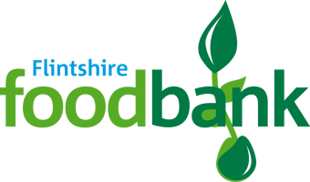
Harvest Collections for the Local Foodbank
This year our Harvest collection will support the Flintshire Foodbank. Our local foodbank helps so many local people and is a lifeline for many of our own local families. Thank you for all the amazing donations so far- you have been so generous!
At Westwood we will be collecting for our local Foodbank. The Foodbank welcome all packaged donations but are in URGENT need of
TINNED/PACKET POTATOES
LONG GRAIN RICE
TINNED/PACKET CUSTARD
TOOTHPASTE
SOAP
TINNED RICE PUDDING
If you can make a Harvest donation towards the Foodbank, please send this into school with your child until our closing date on Thursday 21st October. Each class have a box to collect donations safely, which will be collected by the Foodbank. Your donation will make a real difference — no family should ever go hungry.
For more information on the work of the Flintshire foodbank, please go to https://flintshire.foodbank.org.uk/give-help/donate-food/

