Different types of materials
wood  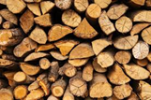 | paper  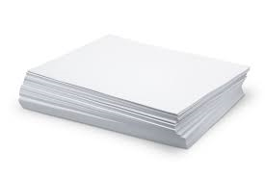
plastic  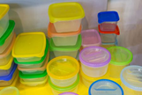 | fabric  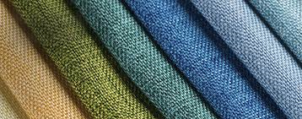
glass  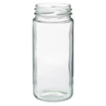 | clay  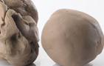
metal  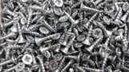 | foil  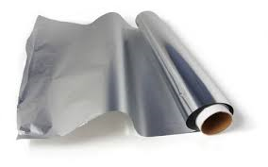
water  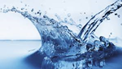 | cardboard  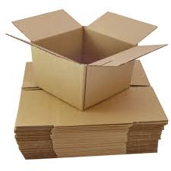
rock  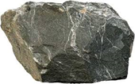 | rubber  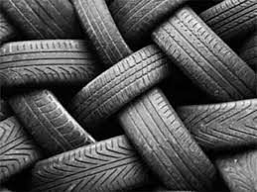
brick  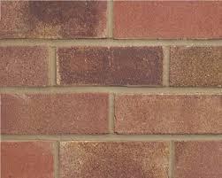 | wool  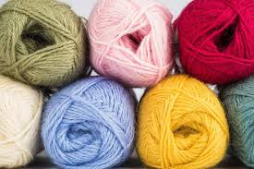
Everyday materials – Year 1
Key vocabulary to describe materials
material – all objects are made from one or more materials.
hard | soft
Stretchy | stiff
bendy | floppy
waterproof | absorbent
breaks | tears
rough | smooth
shiny | dull
see through | not see through
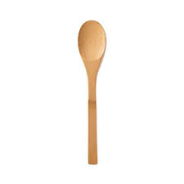 |  | 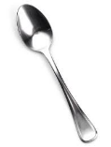  Spoons can be made of wood, metal or plastic.
 |  | 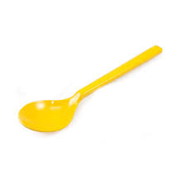
Significant scientists
Charles Macintosh  (1766-1843)  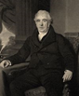 | Scottish chemist and Inventor of waterproof fabric.  The mackintosh raincoat is named after him.
Martin Brock – Nanotechnology engineer and XelfleX inventor
Martin works with a team of scientists developing smart fabrics. They were first created for sports people to wear.

Sorting and grouping materials
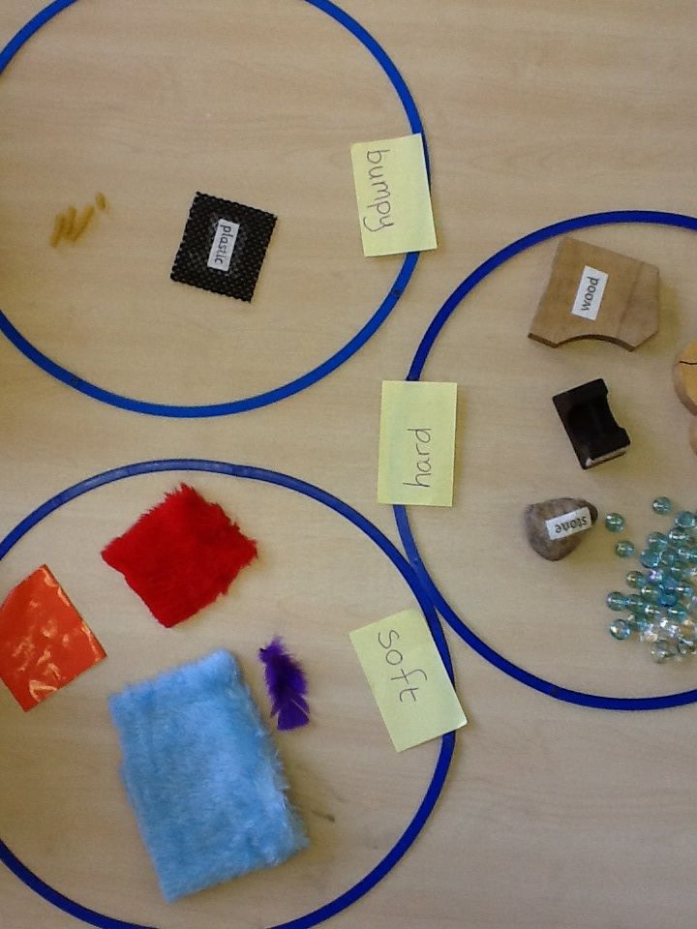
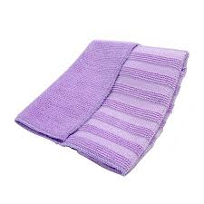
This cloth is very absorbent and soaks up the most water.
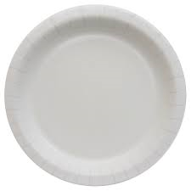
This paper plate would be the best for a party because it is very stiff.
Waterproof materials
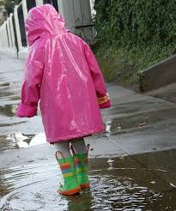 | 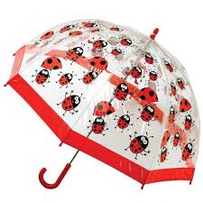  These materials do not let water pass through them.
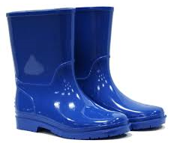 | 