Key vocabulary
light | We can see objects because our eyes can sense light.
dark | Darkness is the absence of light.
light source | Some objects emit their own light and are sources of light.  the sun lightbulbs candles
light source | 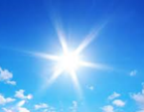 | 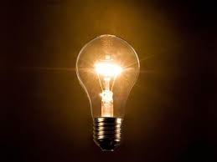 | 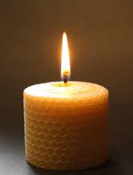
transparent | A material that is completely see through so all the light can pass through.
translucent | A material that lets some light through but not all of it.
opaque | A material that light cannot pass through. You cannot see through it.
shadow | These are formed when an object blocks light.
reflect | When light bounces off a surface.
mirror | A sheet of glass or metal that reflects light.

Sunlight
- The light from the sun can be dangerous.
- It can damage our eyes.
- We must never look directly at the sun.
- We can protect our eyes by wearing sunglasses or sunhats in bright sunlight.
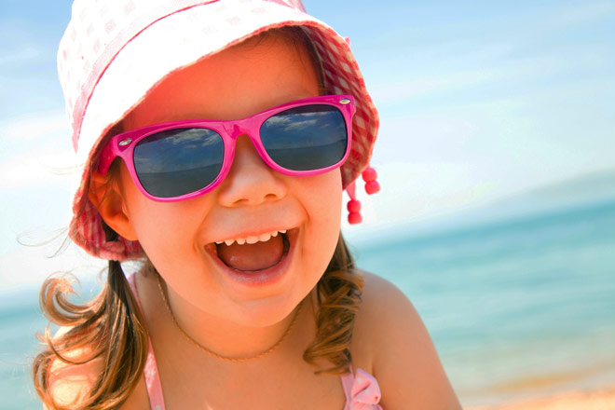
Light – Year 3
Significant scientist
Justus von Liebig  (1803-1873)  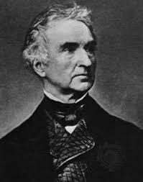 | Justus von Liebig was a German chemist. In 1835 he developed a process for applying a thin layer of metallic silver to one side of a pane of clear glass. This technique was soon adapted and improved, allowing for the mass production of mirrors.

Reflecting light
Shiny surfaces reflect light very well.
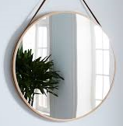 | 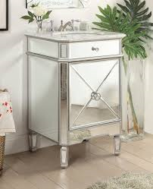
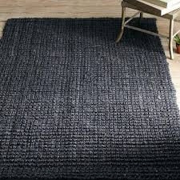 | 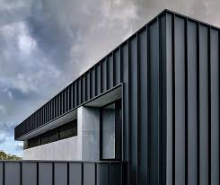  Matt surfaces don’t reflect light very well.
Why do we need light?
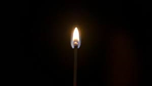
If it’s completely dark then there is no light.
We need light to see things.

The more light there is, the easier it is to see objects.

Shadows
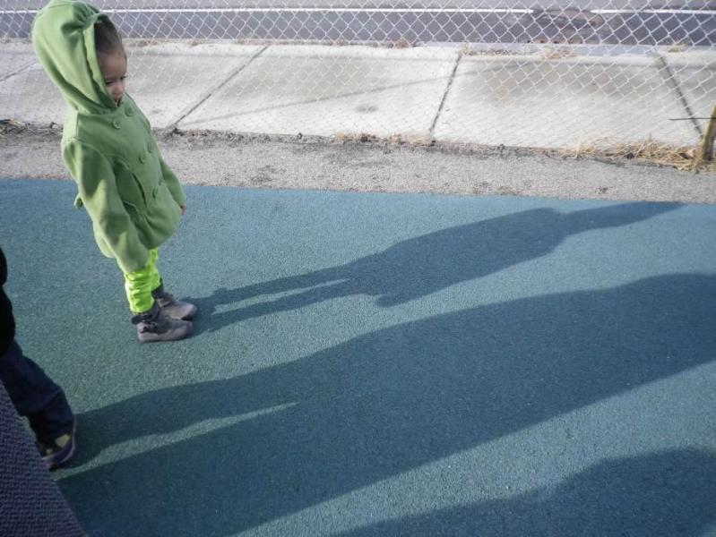 | Shadows are formed when an opaque object blocks the light.  The child is blocking the sun’s light.
We can change the size of the shadow by changing the position of the:  - light source  - object  - surface where the shadow is being made. | 