Key vocabulary
force | A force is a push or a pull.
magnetic force | An invisible force that attracts magnetic metals.
magnet | Magnets attract magnetic materials. Iron, nickel, cobalt and materials that contain these (e.g. stainless steel) are magnetic.
attract | To pull towards.
repel | To push away.
poles | Magnets have two poles, a north pole and a south pole.
contact force | Many forces need contact to act:
contact force | 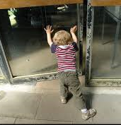 | 
non-contact force | Magnetic force does not need contact and can act at a distance.

Objects moving on surfaces:
 | Ice skates have a sharp blade. This helps them move better on ice.
 | It is much harder to walk on ice in trainers.
A bowling green is closely mown so the grass is short and the balls roll easily. | 
Forces and magnets – Year 3
Significant scientist
Michael Faraday (1791-1867)  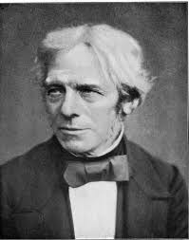 | Michael Faraday was an English scientist.  In 1831, he discovered electromagnetic induction. This was a very important discovery for the future of science and technology.

Types of magnets:
Bar  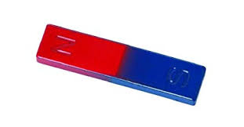 | Ring  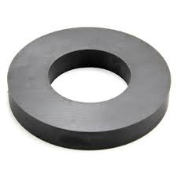
Button  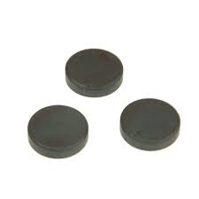 | Horseshoe  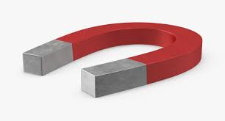

Magnets have two poles
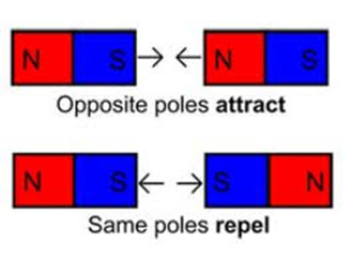
A magnet attracts magnetic materials.
These metals are magnetic:
iron nails  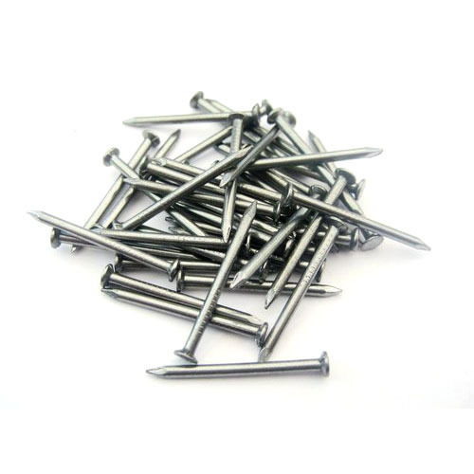 | nickel
 | 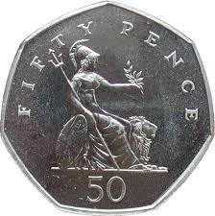 | 50p coins contain nickel
stainless steel  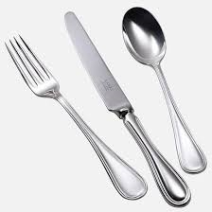 | steel  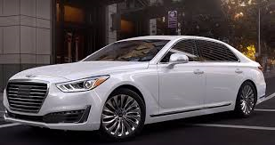

We can sort and classify materials as:
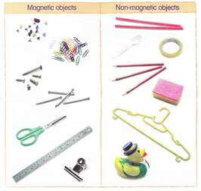
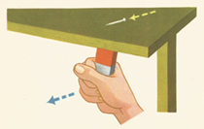
A magnet does not need to touch an object to attract it.

