Spring One, week 4: 27/01/2025 Y6 Spellings: Y3/4 words Ms. Lennox-Douglas

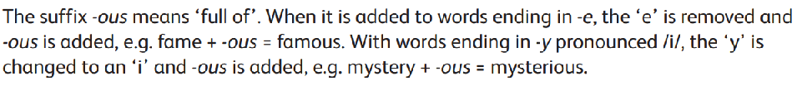
- fame
- famous
- adventure
- adventurous
- joy
- joyous
- ridicule
- ridiculous
- fury
- furious
- prosper
- prosperous
- poison
- poisonous
- mountain
- mountainous
- hazard
- hazardous
- nerve
- nervous
- space
- spacious
- mystery
- mysterious

