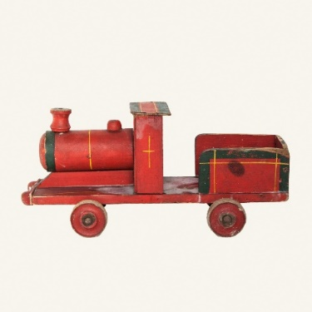
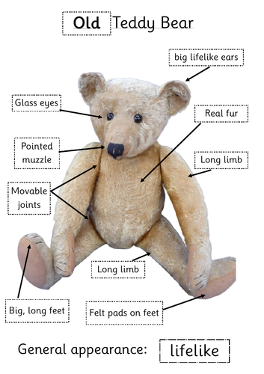
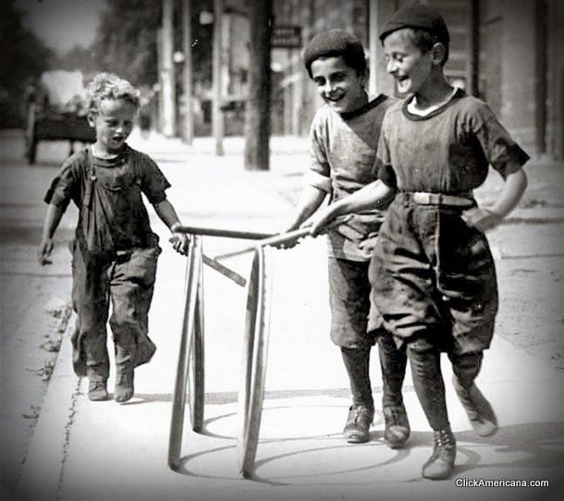
Key Vocabulary and Terms:
What is the same?
What is different?
old/er
new, modern
past, present
change
grow
young/er
museum
evidence
new-born, baby
toddler, child
A long time ago…
They used to be like…
When my grandma was little…

How could you describe these toys?
What are our toys like today?
Who would play with these toys?
How can we tell these toys are old?
What toys did our grand parents play with and how do we know?
Key Objectives
Children:
*develop an understanding of the terms
same and different and begin to use them
*start to distinguish old and new
*sort by colour, shape and material,
*start to generate their own questions
* describe how toys change as children grow older
*match toys to children of the right age
*give reasons why an obviously old toy is old, focusing on signs of wear and material, possibly design too.
* describe changes across two generations.
*use language such as. ‘They used to be like’, ‘When my Nan was a girl’
*carry out a simple survey, interviewing grandparents and posing relevant questions.
* show that they can identify old toys
*make sensible selections of old toys which are clearly different from today’s
*explain why their chosen toy is old
* communicate their understanding of old toys and who would have played with them

Toys through time!
Year 1

