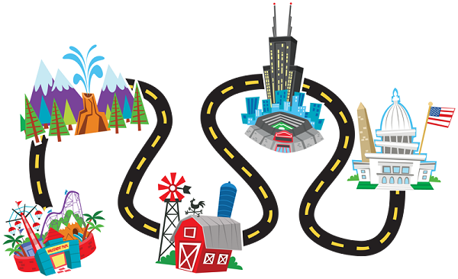
Our Local Area
What will we be learning?
- Differences between urban and rural areas
- Features of our school grounds.
- Features of our local area
- How to identify Ordnance Survey map symbols
- How to create a map of our local area
Key Vocabulary:
Address
City
Rural
Urban
Physical features
Human features
Local
Map
Direction
Distance
Journey
Route
Travel
Left
Right
Straight on
North
South
East
West
Key Knowledge
An urban area has lots of people living there. Towns, cities and suburbs are all urban areas.
A rural area has fewer people living there. Rural areas include the countryside, villages and hamlets.
An Ordnance Survey map is used to help people find their way around an area.

Glossary
map symbol: a small picture on a map that shows you where different things are (such as a bus station or a school)
route: how you get from one place to another (for example, “you walk up the hill and turn towards the school when you get to the top)”
physical features: like seas, mountains and rivers are natural. They would be here even if there were no people around.
human features: like houses, roads and bridges are things that have been built by people.

Types of houses
Flats/Tower block
Semi detached house
Bungalow
Terraced house
Detached house
Maisonettes

