Changes
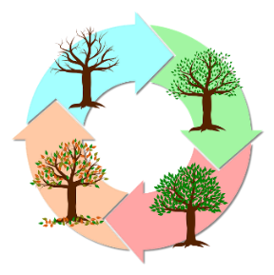
Seasons change
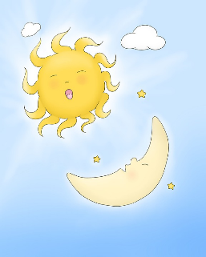
Day changes to night

RHSE – Year 1 – Health and Wellbeing – GROWING UP!
Will I always be a child? What are the 5 stages of life?
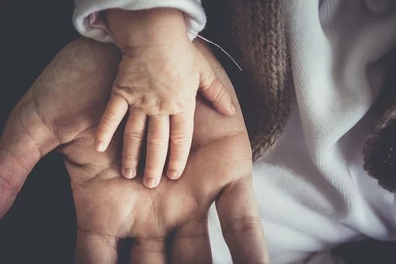
Key vocabulary
Baby
Child
Teenager
Adult
Elderly
Change
Age
Youngest
oldest
Responsibility

Can you put these photos in the right order?
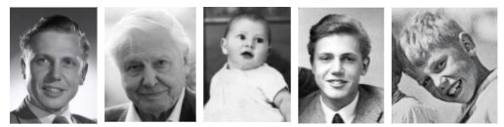



Is it better to be older or younger?
Do we all grow up in the same way?

