Key vocabulary
digestive system | The organs in your body involved in the digestion of food.
digestion | This is the way the body breaks down food so the body can absorb it.
herbivore | Animals that only eat plants.
carnivore | Animals that eat other animals.
omnivore | Animals that eat both plants and animals.
producer | All green plants can make food in their leaves. They are the only producers of food.
consumer | Animals that eat plants in a food chain.
predator | Animals that catch and eat other animals.
prey | Animals that are hunted and eaten by predators.
food chain | Animals eat plants or other animals. The way this happens is shown in a food chain.

Teeth
Humans have 4 types of teeth:
- incisors – used for cutting
- canines – rip and tear food
- molars and premolars – for grinding and chewing food

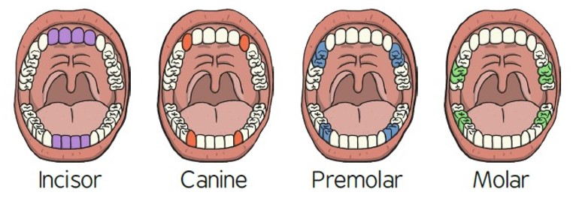
Animals including humans – Year 4
Significant scientist
William Beaumont  (1785-1853)  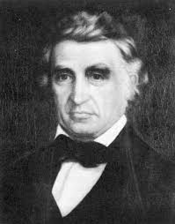 | William Beaumont was a surgeon in the U.S. Army. He carried out lots of experiments and research on human digestion.  As a result, he provided the world with new information about the digestive process in living human beings.

Food chains
= is eaten by
algae  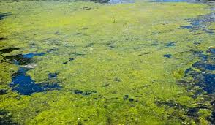 | tadpole  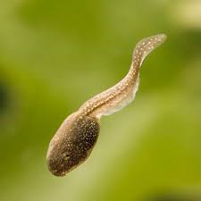 | fish  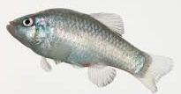 | stork  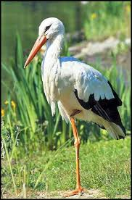
grass  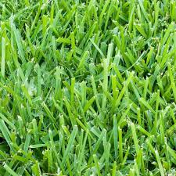 | beetle  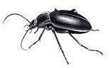 | mouse  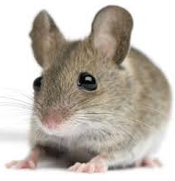 | fox  

Lion skull
Lions are carnivores. They have big canine teeth to help them catch their prey.
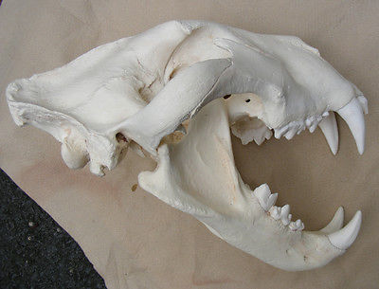
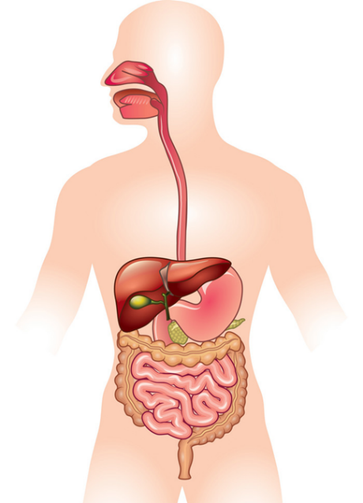
anus
large intestine
stomach
rectum
small intestine
oesophagus
mouth and teeth
The main parts of the digestive system:
- Food enters the body through the mouth
- The teeth start to break the food down. Saliva is added and the tongue rolls the food into a ball.
- After swallowing, the food passes down the oesophagus to the stomach
- In the stomach the food is broken down further by being churned around and some chemicals are added.
- Food passes into the small intestine. Here nutrients are removed from the food to be used elsewhere in the body.
- The rest passes into the large intestine where water is removed to be used elsewhere in the body.
- What is left is then stored in the rectum until it leaves the body through the anus when you go to the toilet.

