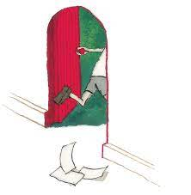
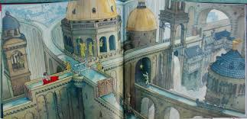
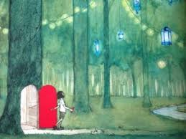
Grammar
- Use a dictionary to find out synonyms.
- Descriptive sentences including prepositions and expanded noun phrases.
- Use a variety of punctuation within writing (full stops, commas, inverted commas, exclamation marks).
- Use pronouns appropriately.
- Use present perfect.
Reading
- Be able to use inference skills when exploring pictures in the book.
- Discrete reading lessons focusing on inference skills.

Writing
- Write a prediction based on the front cover and blurb (to discuss)
- Write a letter (to entertain)
- Be able to create our own journey based on the pictures in the book (to entertain)

Cover
