A cold start to 2025!
It seems like Christmas was a long time ago, but our children have settled back into school and are working hard despite the disrupted start to the year due to the heating and the snow. Mrs Murray and Year 3 have settled together so well.
Dates for your diary
Friday 6th Feb – Number Day. A celebration of maths in school. Wear any maths related clothing (numbers, shapes or patterns!) with a donation of £1 to the NSPCC. Cash only please.
Swimming for Years 3 and 5 will commence next week for two weeks.
Wed 4th Feb- Wellbeing workshop for Y1 and Y2 parents who have signed up. There are still some places available. 9am -10.30 am
Thursday 12th Feb 1.30pm. Year 4 will be having a sleep and screens workshop which parents are invited to attend. Please let the office know if you will be joining us.
Friday 13th Feb Wear what you love Day £1 contribution to school fund which can be paid on School Hub if this is easier for you.
Wednesday 25th Feb Year 5 will be attending Crucial Crew. School is funding our attendance at this as we feel it is important that children know all about our emergency services, but we are asking for a £5 contribution towards our transport. This should be paid on School Hub.
Thursday 26th and Friday 27th Feb The Life Caravan team will be in working with the children.
Advance notice- Parents Evening will be on Tuesday 24th and Wednesday 25th March. More details to follow.

Clothes give away
Following on the success of this last year we will once again be holding a uniform give away on Tuesday 24th February. If you have any good quality uniform (no stains, rips etc.) which no longer fits your child then please have a sort out at half term and donate it to school on the Monday or Tuesday after half term. Check those summer dresses! We are particularly happy to receive any older age clothes as we have a shortage of these in school in case of emergencies. We will be opening the hall at the end of the school day for you to come in and help yourselves to any uniform that your child could use. Bring a bag and help the environment and your pocket. No charge though donations to school fund are welcome.
Term dates for next academic year.
We have had parents asking about our holidays for 2025-26. Our dates for next academic year have now been set and are on the school website. The office can also provide a copy on request. School will start for children on Thursday 3rd September. If you are planning holidays, please bear these dates in mind as holidays in school time cannot be authorised.

Reminders:
Just a little reminder that only school cardigans, jumpers or hoodies should be worn on PE days with the school PE top. Trainers should not be worn for school unless it is PE day. If they are worn short term due to an emergency shoe situation then please inform the class teacher.
Help and support
Please apply for free school meals if you think that you may qualify, even if your child is in KS1. School benefits from extra funding in this way, and you may get food vouchers for school holidays. Link is here.
https://www3.halton.gov.uk/Pages/EducationandFamilies/Schools/FreeSchoolMeals.aspx
If any families are in need, we can refer you to foodbank. Please let us know if you need this help at any time.
Attendance and punctuality
We have been selected to be part of an ‘Attendance Hub’ as our attendance is in the lowest 10% in the country and have been set a target by the Government to achieve by the end of the year. With your support and understanding of how important attendance is, we are currently on target to meet this, but only just, so please ensure that children are in school whenever they are well enough to attend.

Our whole school attendance for January: 93.62 %. Well done to Year 2 for the best attendance this month!

Reception 92.45%
Year 1 96.18%
Year 2 96.76%
Year 3 92.32%
Year 4 95.95%
Year 5 91.99%
Year 6 89.71%

School Dinners
Orian are introducing a ‘packed lunch’ option which may be easier and cheaper than making your own packed lunches at home for those families who qualify for free school meals or who would rather pay someone else to make them! The packed lunch option will consist of a choice of sandwich / wrap or pasta pot, fruit wedges, veg sticks and raisin & sultanas plus the dessert of the day. This will be introduced after half term and will replace the sandwich option.
Halton Education Awards
We are delighted that two members of our staff were shortlisted, and then won categories in the recent Halton Education Awards.
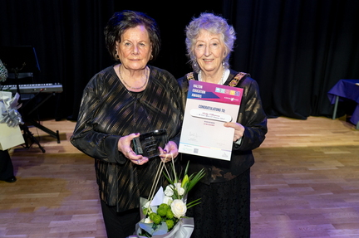
Mrs Edinborough won Support Star of the year, and Mrs Williamson from our lunchtime staff won the lifetime achievement award for her long service to the school. Both very well deserved!

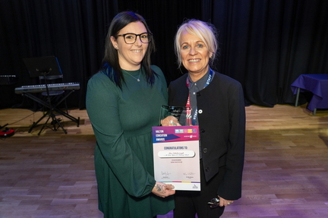

Parental Questionnaire
Thank you to those parents who have completed the school questionnaire. We have included the results from this with the newsletter.
Mrs. McCann

