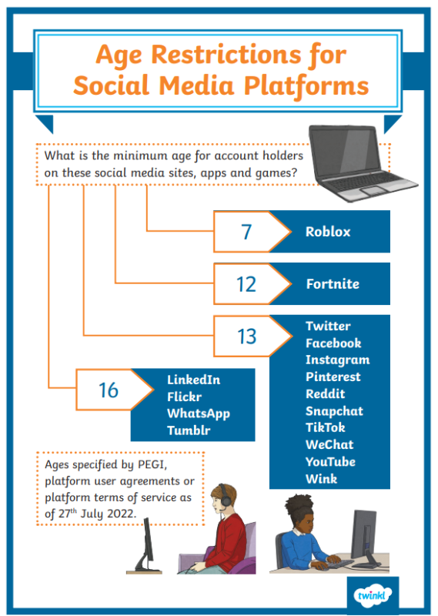
Dates for your diary
We return to school on Mon 13th April
Wed 15th April- Year 5 go to Condover Hall
Wed 22nd April- Year 5 Puberty talk as part of our science curriculum
Thurs 23rd April- British Values Day. Children will be having activities in class.
Fri 24th April Dress up for Malawi Day. £1 donation to support Jack Lawson and the Malawi event. Details to follow
Tue 28th and Thurs 30th April- Come and see our Art exhibition and purchase your child’s amazing contribution! Details to follow.
Dinners
Please make sure that you place your orders over the holidays for the first week back.
Reminders
Please ensure children, including younger brothers and sisters, do not use equipment from the trolleys at the beginning or end of the day, or go on the play equipment. Although we are waiting for a date for repairs for the KS2 equipment it is currently unsafe to use, even with adult supervision.
Easter Decorating competition
We had some amazing entries which you will be able to see on Seesaw.

Internet Safety
We have been advised by a parent that their child has accessed inappropriate content while watching YouTube kids. While you are responsible for your child’s usage please remember age restrictions. Instagram also has a ‘teen’ setting for 13–17-year-olds to ensure their safety when they are old enough to access it.
Attendance and punctuality
Whole school attendance for March: 89.17%. Hopefully we will have a better April! Well done to Y5 for the best attendance this month.
Reception | 88.67%
Year 1 | 87.76%
Year 2 | 90.72%
Year 3 | 87.68%
Year 4 | 90.53%
Year 5 | 91.39%
Year 6 | 87.44%
Wishing you all a peaceful and relaxed Easter.
Mrs. McCann

