October
How quickly has this half term flown! It seems like such a short time since we started back in September. Our Reception children, and those who joined us in other years have settled in so well and it feels like they have always been with us! I hope you were able to chat with your child’s teacher about the progress they have made at Parents Evening last week. The staff have all commented on how well most our children have adapted to their new classes and how well they are doing at following our school rules and showing our Christian values.
Dates for your diary
Friday 24th Oct Harvest Festival ( year 6 parents) End of term 3.20pm
Tuesday 4th Nov Return to school
Friday 7th Nov Book Fair-details to follow
Wed 12th Nov Disco
Wed 26th Nov Flu vaccines
To add to your diary for December…
Thurs 4th Dec Reception and Y6 trip
Mon 8th and Tue 9th Dec KS1 Nativity
Fri 12th Dec Christmas Jumper Day £1 for Save the Children
Mon 15th and Wed 17th Dec KS2 Christmas Performance
Thurs 18th Dec Christmas Party Day
Friday 19th December End of Term 1.10pm. Please note that registers are taken before children are sent home so this does count as one session of attendance.

School Disco
As mentioned above we will be holding a school disco on Wednesday 12th November. The cost for this will be £2.50 which includes refreshments. We will be welcoming back TJ the DJ who ran our disco last year with one child commenting that it was the best day of his life!
KS1: 3-4pm. Children to come to school dressed in their disco clothes. Any child who does not wish to attend should be picked up at 2.50pm
KS2: 4-5pm. Children will go home and then return for the disco. All children MUST be collected at 5pm, no one will be able to walk home alone.
Please bring money in a named envelope from tomorrow onwards. Children will not receive tickets but their name will be added to a list for entrance.
If we are concerned that any children will not follow our behaviour expectations at the disco then they can be told they will not be attending and money can be returned to you.
Remembrance Day
Poppies and other items will be available on sale from Tuesday 4th-Tuesday 11th November. Poppies are 20p and wristbands etc. are 50p. Y6 children will come to the classes to sell these. If any parents would like any items these can be bought from the office.

Reminders:
- Earrings should not be worn for school. If they have to be worn they must be small, plain studs only and need covering for PE. Please note children will need to bring their own plasters if they are unable to remove them for PE.
- Could I also ask all parents to ensure that their children stay with them until they get to their classroom first thing in the morning rather than running ahead. Much as it is lovely to see how keen they are to get into school, I am concerned about any trips or falls as they move through the playground.
- All children going to Condover Hall need to have paid £60 deposit by 31st October
- Payment for Farmer Ted’s for Reception and Y6 should be paid as soon as possible.

Sponsored Skip
Following our fun day with the Skip2BeFit team, the whole school have been very determined to improve their skipping scores. Year 6 went a step (or skip!) further and held a sponsored skip on Friday 17th October to raise money to support with the cost of the coach for their school trip and for other school events. They skipped in groups all day (including the staff), completing over £74,000 skips and made an amazing £1114! Thank you to Mrs Geraghty for organising the event, the children for all their hard work and also to those parents and family who sponsored them.
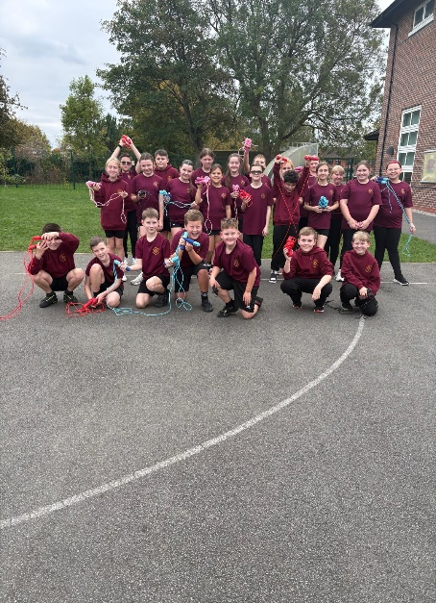

Allergies and packed lunches
A reminder that we have children in school with a variety of allergies. Therefore children must not bring any nuts or nut related items in packed lunches. This includes peanut butter, hazelnut spread including Nutella etc. However, you can get nut free versions of this. Also please ensure children’s lunches are healthy as possible with no sweets or chocolate bars.
Attendance and punctuality
Please remember to contact us on every day that your child is absent. We understand that there have been lots of bugs and illnesses around in the last few weeks so hopefully we’ll all be back to full health after the half term holiday.
Our whole school attendance for October: 92.6%
Reception | 89.8%
Year 1 | 91.2%
Year 2 | 96.6%
Year 3 | 90%
Year 4 | 95.1%
Year 5 | 92.6%
Year 6 | 92.9%
Well done to Year 2! Best attendance in October
Help and support
I always remind parents about applying for pupil premium, even if your child gets free school meals in KS1. This ensures that we receive extra money in school which can be spent on supporting all our children. It also means that during school holidays you may be eligible for any food vouchers which the council provide.
The link is here:
https://www3.halton.gov.uk/Pages/EducationandFamilies/Schools/FreeSchoolMeals
I also wanted to make you aware of a scheme which you can use if you use breakfast or after school clubs. This provides up to £2000 a year to help with the cost of childcare. I hope this will be of help to some of you.
https://www.gov.uk/tax-free-childcare
Enjoy half term
Mrs McCann

