All Saints Upton C.E. Primary School
‘Let all that you do be done in love’
1 Corinthians 16:14

Love Hope Perseverance Thankfulness Forgiveness Trust

Headteacher: Mrs J McCann

ATTENDANCE NEWSLETTER

We are including extra information in this newsletter to ensure that all parents are aware of our new attendance initiatives. Our school continues to have attendance which is well below national average, and below most Halton schools. Whilst we know that children are poorly, and fully support these absences wherever possible we do encourage children to aim for full attendance.

Good attendance really does make a difference to your child’s progress, even from Reception. They are learning new things every day and absences can bring about gaps in learning which are often very difficult to make up, especially if these absences are regular and often. It is for this reason that we promote good attendance.

REWARDS
Last year, we brought in a class attendance award for each week, with an extended playtime as a reward and one child from the winning class also became a VIP for the week. This year, we have developed this so that each week builds upon the last with classes receiving extra rewards as the term goes on. We have created a racetrack in the heart of the school so that classes can track their progress. We will also update parents via Seesaw weekly as to who has achieved this. Last year, we also introduced termly certificates for outstanding, excellent and improving absence. These will continue.

We also took on board the children’s feedback that even if they were in all the time this was affected by other children’s absence, so we have brought in an individual challenge. For every week that a child has 100% attendance they will receive a raffle ticket for a prize at the end of each half term. The more raffle tickets the more chances they will have. We hope that as many children as possible will aspire to this achievement.

ILLNESS
All parents are aware of our routines for reporting absences, and we are grateful that so many of you follow these. If your child is poorly their absence will be authorised in line with medical recommendations e.g. 48 hours for vomiting and diarrhoea. However, if this illness brings your child’s absence to 90% or below then medical evidence will be required for all absences, otherwise they will class as unauthorised. This is even the case if the reason for your child’s previous absences have been a holiday.
For example- your child was absent early in the year due to an unauthorised holiday and their attendance falls below 90%. They then have an illness. Medical evidence will be required even though they have not had absences for medical issues previously. School will always contact you to confirm that medical evidence is required even if you have informed us of your child’s absence.

HOLIDAYS, UNAUTHORISED ABSENCES AND FINES
We have an assigned Education Welfare Officer who works closely with school to monitor attendance. The authority impose fines for any holiday absences of 5 days or more. Although these are sent from the school we are under an obligation to the local authority to impose these and it is only in truly exceptional circumstances that it is possible to authorise these.

However the authority, in line with Government ruling, may now also impose fines for any child who has 10 unauthorised absences within ten weeks, so that even if a child has not been on holiday for 5 days in succession this can still be triggered if they have 10 unauthorised absences within a specified time period. Please note, this does not include illnesses that we have medical evidence for as these are classed as authorised.

As such, school is now also required to follow this ruling from this academic year. The EWO will contact any parent who is approaching this amount to advise you. If the threshold is met then the authority will automatically send a notice to improve letter.

Please also note that if a child arrives at school after 9.20 this is classed as an unauthorised absence so even 10 lates after this time in 10 weeks would trigger this. However, you cannot receive 2 fines (one for a holiday and one for the 10 sessions) for the same time period.

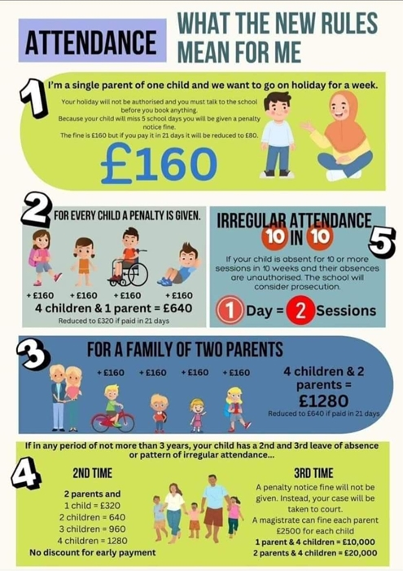
Thank you for working with us to ensure that your child has the best chance to succeed.

Mrs J. McCann (Headteacher)

