A lot of information this month!
Dates for your diary
INSET dates for 2025-2026 are 1st and 2nd September, 3rd November, 1st June and 20th of July, meaning that in 2026 school will finish on 17th July. All other holiday dates are in line with Halton schools which can be found on our website.
Dates for the rest of this term:
1st July- Y6 trip and KS1 Sports Day
2nd July- Infant music festival and Y3/4 Sports day
3rd July- Y5/6 Sports Day
4th July CO workshops for Y3 and Y5
7th and 8th July Y6 Transition days
9th to 11th July Y5 residential to Condover Hall
14th July French morning- all children are invited to dress in the colours of the French flag!
15th July Y6 play (1.30pm and 6pm- details to follow)
16th July School Quiz
17th July pm Leavers’ service and final assembly. Y6 parents are invited to attend. Times to be confirmed.
18th July End of term 1.10pm
All children will return to school on Wednesday 3rd September. Any children joining Reception will start on Thursday 4th September.

Farewells
We have a few members of staff leaving us this year. We would like to say goodbye and thank you to Mr Finney, who has worked with all the classes throughout the school and Miss Burgess who has worked with Year 6 since October. We also have some staff who have worked with particular children who will also be moving on to new roles. We wish them all success for the future and thank you for all you have done during your time with us. Mrs Howarth in the office is not leaving us (thankfully!) but her last day in school will be Friday 4th July as she is taking some holiday time owed. We would be grateful if you could bear this in mind if contacting the office in the last two weeks of term.
The children will meet their new teachers on the afternoon of Monday 7th July. Please see attached sheet. Some of the children in school will have extra opportunities to spend time in their new classroom or with their new teacher to aid transition.
Uniform
From September we will be introducing a new PE top. All children will wear the same sports style top in the school colours. There is no need to replace the top you originally have if you would prefer to wait until your child has grown out of it to buy a new one. The new top is available at Kits4All from tomorrow. As the kit list states this must be worn with plain BLACK shorts, or leggings or jogging bottoms for the colder weather. Children must also wear their normal school jumper or cardigan or the PE hoodie which can only be worn on PE day. The uniform list is available on the school website. Our only supplier for school badged items is Kits 4 All.
School dinners and support
Please make sure that you order school dinners through the School Hub website, especially for our return to school in September! Please ensure that you complete your orders on the website even if your child has a packed lunch. Children are not able to order in school unless there is a specific reason. A reminder to apply for free school meals if you qualify as this provides you with vouchers for over the school holidays too.
Attendance
Please see attached poster which we have created to ensure that you are clear as to the fines which will be implemented if your child has unauthorised absence in the next academic year. We encourage all parents to work with us on supporting good attendance and not take holidays in term time.
Fundraising
Thank you for all your support with our fundraising this year. Last week’s toy sale raised an amazing £510! The sales and own clothes days this year have been a great success and have ensured that we have been able to subsidise the cost of coaches and provide resources and activities that we could not otherwise have done.
Events
We were delighted that Evelyn and Mariia from Year 6 were able to collect our Halton Healthy Schools Award at the stadium this week.
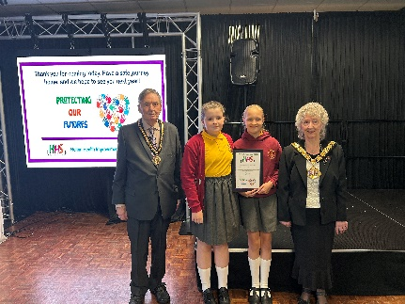

The children in KS2 who attended all had a great time at Town Sports.
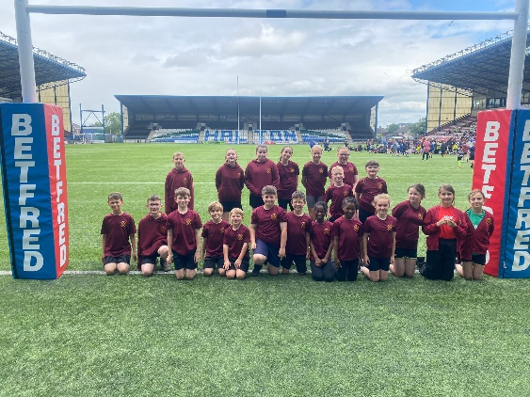

Year 3 had an amazing overnight adventure at the Catalyst Museum.
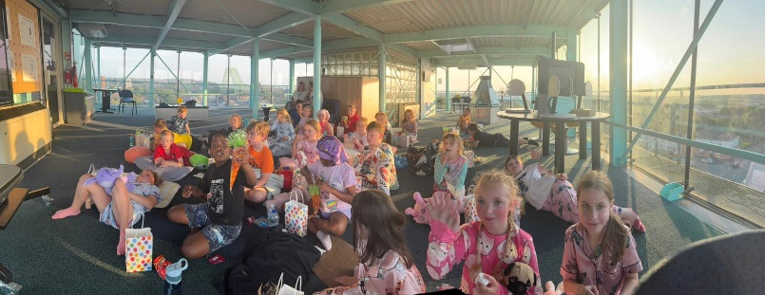

This will be the last newsletter of the academic year. Children’s reports will be sent out on Wednesday 9th July. Thank you for all your support this year, and I wish you all a happy, relaxing summer.
Mrs. McCann

